Georgia Tech BIM Requirements & Guidelines for Architects, Engineers and Contractors | January 15,  2016
These BIM Requirements applies to Georgia Institute of Technology A/E/C selections advertised after January 1st, 2016. BIM methodology is required for all construction projects.  Issue Notes:  This document supersedes the “Georgia Tech BIM Requirements & Guidelines for Architects, Engineers and Contractors” BIM guidelines 1.0, issued 2011, and named “2011_0815_GT_BIM_Requirements_v1.0”. | Version 1.5

Contents
1) BIM Requirements 3
2) General Requirements 3
3) Reference Requirements 7
4) BIM Proficiency 7
5) BIM Execution Plan (BEP) & Integrated Project Methodology Plan (IPP) 8
6) Open Architecture for Interoperability 8
7) Data Validation Concept 9
8) GT BIM Revit Template 10
9) Model Quality 10
10) Interference Checking. 11
11) Space Validation 13
12) Energy Requirements Overview 13
13) Project Team Deliverables 13
14) Objectives and Applications 16
15) Energy Information Modeling (EIM) Requirements 17
16) Information Exchange 17
17) Interference reporting 23
18) Program and Space Validation 24
19) Systems Cost Estimating 24
20) COBie Design Data 24
21) Construction Documents phase 25
22) Agency Coordination & Bidding Phase 27
23) Construction phase 28
24) Coordination Meetings 30
25) Projects without active .RVT models at the start of construction. 30
26) Projects with active .RVT model at the start of construction. 31
27) Project Closeout Phase 32
28) Ownership and Rights of Data. 34
29) Appendix 34
30) GT Facilities Management System Data Structure 35
31) COBie Data Roles and Responsibilities 37
32) Central File Conversion Guidelines 37
Terminology 39
References 42

BIM Requirements
  - Overview
        - The intent of these requirements is to create a prescriptive framework with which Building Information Modeling (BIM) enabled teams will coordinate with Georgia Tech, the Board of Regents, the Georgia State Finance & Investment Commission, and other applicable groups on requirements to being BIM compliant. This document will allow all stakeholders to weigh the importance of each requirement on a per-project basis. Through this collaborative effort, a final project-based set of requirements and corresponding BIM Execution Plan will be issued based on what level of BIM proficiency necessary for a given project.
        - Georgia Tech (GT) requires that all design and construction deliverables for all construction projects be created and derived from building information models, and expects that data associated with the installed components of these facilities be reconciled and validated with the construction deliverables.
        - GT will use these models and associated data for facility lifecycle management. Building information models shall be provided throughout the design, construction processes and close out phases. This includes corresponding building data collected and communicated using the Construction Operations Building Information Exchange (COBie) to capture, record, and use close out data. COBie is an information exchange system that is used to collect building data in a spreadsheet format. It can be tied to BIM for efficiency and used to assign building components unique naming conventions outlined later in this document. This information will be validated through GT’s data management processes. Unique Globally Unique Identifiers (GUIDs), assigned in the BIM authoring tools, will be maintained to support data in workflows that can then be used throughout the design, construction and building commissioning process.
        - Portions of this life-cycle oriented data format will be required for various building information deliverables replacing paper deliverables. The deliverables for the Close-out in COBie format include, but are not limited to:
          - Verification of the design solution against the Program for Design
          - Scheduled building equipment/component lists
          - Construction submittal register requirements
          - Identification of installed equipment and all tagged building products
          - Close-out deliverables

General Requirements
  - The procedures and protocols with respect to the development and management of a Building Information Model (BIM) by the Project Team throughout the course of a project shall conform to AIA Document E203-2013 or current version.
  - In general, geometry should be modeled at a level of development (LOD 300) to guarantee the model components and associated data match the project phase expectation, and contribute to the critical path modeling strategy across all disciplines. Development of the E203 document will be used in conjunction with the BIM Execution Plan. Specific modeling approach, model exceptions, tolerance, and model component field access requirements are examples of items to be addressed in the AIA E203 document.
  - Listed below are graphical representations of how the different levels of detail (LOD) specific to each discipline. BIM LOD Samples for Architectural, Structural, and MEP Disciplines. Image credit for Figures 1, 2, 3 Image by BIM Forum.
Figure 1:
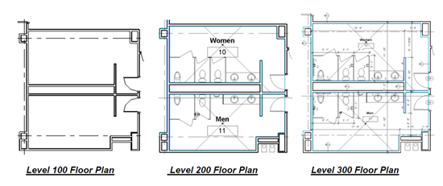
Figure 2:
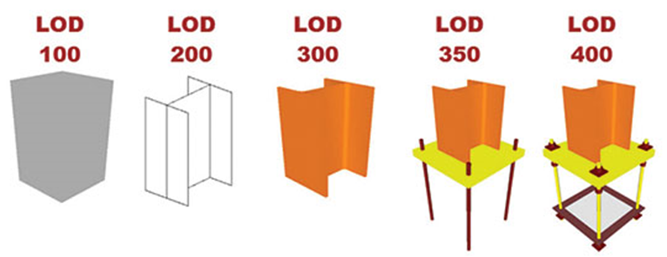
Figure 3:
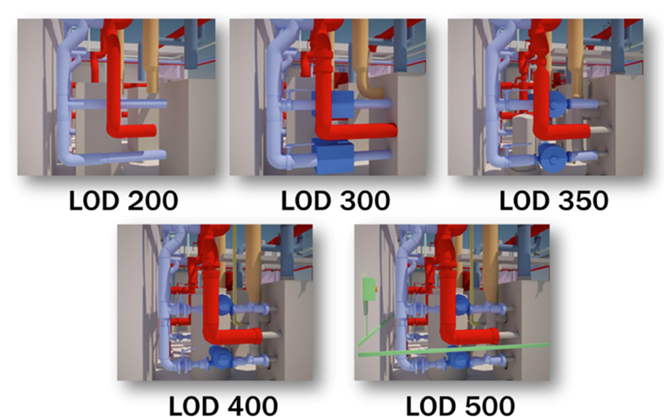
  - All land surveys and Building Construction projects must be tied to the State’s GIS GA State Plane West, NAD83 (1991) coordinate system and USGS datum.
  - Building information models shall be created by the Design Team to include all geometry, physical characteristics and product data needed to describe the design and construction work. All drawings and schedules required for assessment, review, bidding and construction shall be derived from these models either directly (as in schedules, floor plans, etc.) or indirectly (as may be the case with details). The Project Team shall follow the guidelines and requirements detailed in this document for BIM related services. Deliverable requirements are specified later in this document.
  - Time stamps will be added to models prior to design milestone deliverables and reviews. Time stamp data is to be apparent within the deliverable report for model correctness. Time stamp text information should be placed within the title block of the project as well as appended at the end of any submitted file(s).
  - Interference checking (or collision detection) with tolerances listed below, is required for major milestones for GT projects. The Design Team may submit for use any interference checking software that can perform to the following specifications in this section. See section 10 for a list of priorities for object interference.
    - A collision may be defines as:
      - A “hard” interference is where the geometry of different objects such as structural beams and ductwork overlap/intersect. A hard interference is any geometry that has an overlap of greater than 2 inches.
      - A “soft” interference is where a predefined clearance or reserved space surrounding an objects geometry overlaps/intersects, such as conduit and structural beams with another object. A soft interference is any geometry that has an overlap of less than 2 inches.
      - A “programmed” interference is where the software being used allows the user to pre-program variable interference requirements based on a set of rules and object types. The following measures should be applied during each project phase:
        - All Design Phase Interferences: If the selected design platform contains internal interference detection and reporting tools, then these tools are acceptable during these phases. Most design software will only report “hard” interferences. Additional reporting for all collision types may come from an external application if the Design Team determines it is required for the project.
        - Construction Phase Collisions: At a minimum, the contractor is required to use software that will report both “hard” and “soft” collisions to further resolve interferences, errors and waste during the construction process.
        - For Design-Build projects, both the designer and contractor are to participate in the authoring of a collaborative coordination plan.
      - Refer to Section 9 in the Model Quality section for additional requirements.
  - The Project Team will deliver files in the most current, stable releases of the Autodesk Revit file format (.RVT); Autodesk Navisworks file format (.NWD) and Autodesk Civil 3D file format (.DWG) available at the ‘official’ project start date. Any further needs should be defined in the project BIM Execution Plan and coordinated with the Georgia Tech facilities group.
  - The Design Team(s) will use the available GT BIM Revit Templates for new and existing renovation projects. The GT provided standard template(s) contains project parameters tied to their facility management systems. All projects utilizing the template(s) will require accurate schedule data that can be exported for milestone deliverable and approval to GT.
  - The GT BIM template(s) will provide GT the ability to internally perform program and space validation, including space identification, room and area data, identification of component level MEP services and interior surface and finish requirements. See Section 8.
  - The Design Team is encouraged to use the GT project collaboration tool such as Autodesk 360 Glue/ A360 Field, “ARC Document Solutions (http://www.e-arc.com)for document management and file sharing. Other collaboration reviewing tools, project communication websites, web meetings, and video conferencing are also encouraged. The collaboration team’s roles and responsibilities will be defined in the BIM Execution Plan.

Reference Requirements
  - GT Space Identification & Room Numbering Guidelines
    - http://www.space.gatech.edu/assets/RoomNumbering.pdf
  - GSFIC Georgia State Construction Manual
    - http://scm.ga.gov/Manual.html
  - Postsecondary Facilities Inventory and Classification Manual (FICM)
    - http://nces.ed.gov/pubs2006/2006160.pdf
  - National CAD Standard
    - http://www.nationalcadstandard.org/ncs6/
  - AIA E203 2013 Digital Information Modeling and Digital Data Exhibit
    - http://www.aia.org/contractdocs/AIAB099319
  - GT Master Planning Standard – Referenced for incorporation into milestone deliverables
    - http://www.space.gatech.edu/masterplan/assets/2004MasterplanUpdate.pdf

BIM Proficiency
  - BIM proficiency is defined as a capability for building information models to provide appropriate information to other systems or processes for reporting and calculation. During project kickoff, the project team will work with GT to define model capabilities for each project. The AIA E203 be used to address the unique nature of integrated projects.
Depending on the project type, project size and BIM Level of Development (LOD), GT may use some or all of the requirements within the AIA E203. GT will define for the Project Team the BIM proficiencies or level of maturity required to match the competencies as outlined below:
    - Physical Accuracy of the Model: Refers to the placement, sizing, and representation of building components. The scale represents a mixture of 3d (three dimensional) and 2d (two dimensional) content at the low end to a fully 3d (three dimensional) model that will be used in interference checking and beyond on the high end.
    - IPD Methodology: Refers to the integration methods that will be used by the team. The scale represents the creation of a BIM Execution Plan (BEP) on the low end to the appointment of model integration managers at the high end. Please refer to section 5 for additional information.
    - Calculation Mentality: Refers to the models’ ability to be exported either as Industry Foundation Classes (IFC) file type, or the Green Building XML (gbXML) file type. Calculations at the low end and the ability for models to modify each other’s calculations at the high end.
    - Location Awareness: Refers to the positioning and accuracy of the model in relation to site coordinates and the sharing of coordinates between models at the low end to accurate global positioning and weather data at the high end.
    - Content Creation: Refers to the information content and accuracy of model objects in relation to size and specifications at the low end to parametric content that responds to model changes at the high end.
    - Construction Data: Refers to the models’ ability to provide accurate (+/- 1%) quantity takeoff at the low end to procurement of materials directly from the model at the high end.
    - As-Built Modeling: Refers to how much the model will be used post-bid; from generating RFIs at the low end to the model and information generated from the model changing as the construction activities drive change at the high end.
    - FM Data Richness: Refers to the level of data available for FM functions such as space management at the low end to asset management and accurate equipment specifications at the high end.

BIM Execution Plan (BEP) & Integrated Project Methodology Plan (IPP)
  - The BIM Execution Plan is a living document that will continue to mature over the course of project deliverable and milestones. The BEP will be reviewed and approved by GT within fourteen days after submitting the BEP for review. The BEP will include assumed roles and responsibilities of the team even if that party has not yet been identified, such as the construction team. Design and construction teams will identify the person(s) within their organizations responsible for managing the BIM(s), or portions of the BIM. Collaborative aspects of the Integrated Project Delivery (IPD) approach are to be harnessed in developing the BEP and IPP mentality.
  - The IPP, integrated within the BEP, should demonstrate a high level of project integration and technological workflows by identifying project methodology and modeling procedures, quality control, and scheduling and model information validation. Examples of IPP’s are, but not limited to, Reverse Phase Scheduling and Critical Path Modeling conforming to level of development requirements. Constraints and model role dependencies are described here. These can be prepared as swim lane diagrams. Although there is no template for the IPP plan, GT encourages high level planning be incorporated in the BEP.

Open Architecture for Interoperability
  - While the milestone deliverables as described in section 2h are specific in nature and are intermediary requirements, GT has adopted open architecture for data exchange. The Project Team may use any BIM software capable of delivering the necessary requirements during the design and construction process but is encouraged to use products based on or using open architecture for greatest interoperability between consultants and GT. The Industry Foundation Classes (IFC) file format developed by the buildingSMART.
IFC provides an interoperability solution between different software applications. This established international file format is used to export and import building objects and their properties between two different software applications. Design Teams will export to IFC format if required.

Data Validation Concept
  - Data validation concept for GT projects: GT requires BIM reporting and analysis to be delivered for predetermined milestones described later within this document. Validation ensures that GT is getting graphics and data in a systematic way that influences their document and facility management systems.
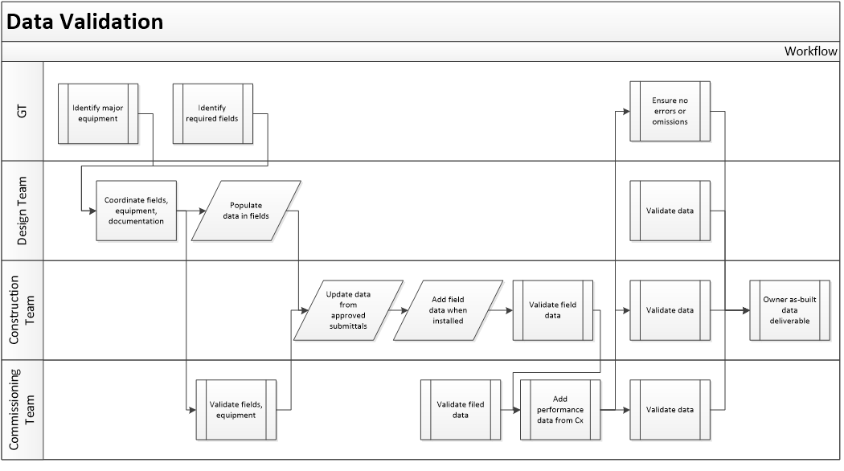
  - Pre-approved Information exchange formats:
    - COBie (Construction Operation Building Information Exchange)
http://www.wbdg.org/resources/cobie.php?rom
The complete COBie spreadsheet consists of several worksheets within a single file. The data rich Microsoft Excel integrates with GT’s design, construction and turnover deliverables. During the design and construction phases, the Design Team will contribute to the single spreadsheet to mitigate data loss and to track data export from the models. COBie is an information exchange tool and there are many ways to add data to the COBie data register. Facility, floor level, space/ zone data, component, building systems, and document data are categorically identified within the models.
    - Building Smart Alliance.
      - http://projects.buildingsmartalliance.org/files/?artifact_id=2612
    - OmniClass.
http://www.omniclass.org/
The project team shall assign the proper classification to the OmniClass attributes field for spaces and components within the BIM projects.
    - IFC (Industry Foundation Class) Current release version 2x3.
http://www.buildingsmart-tech.org/specifications/ifc-overview

GT BIM Revit Template
  - In support of COBie, the project team is required to utilize attributes within the GT BIM template to assist generation of required information for contribution to the GT FM data structure.
  - GT facilities management database systems require data derived from the BIM and exported to the information exchange. COBie 2.O offers matching fields that will contribute to GT’s FM strategic deliverable. See section 31.

Model Quality
  - The Design Team shall establish and use in-house model and information quality control guidelines and exchange protocols. Good BIM practices may include but are not limited to:
    - Use of element and component objects that embed the required data parameters beneficial to meet model roles. The BEP will outline anticipated model and component data parameter requirements.
  - BIM Model managers are responsible for model and data synchronization to guarantee data model consistency across all full and partial models.
To support energy modeling requirements the following minimum requirements must be followed:
    - Revit walls should be modeled accurately to according to their location within the model. Walls along the exterior of the project should their materials organized according to face the correct exterior and interior sides. Interior partitions that have materials on both sides of an air conditioned space should have the “exterior” components of the Revit wall face towards the predominately public side of a space.
    - Walls should be modeled so there are no gaps in exterior walls so that the boundary between inside and outside is incomplete.
    - Additional requirements for energy modeling will be defined by the Project Team in the BEP, and approved by GT. Refer to Georgia Tech’s Yellow Book for additional Energy modeling requirements.
    - Use GT defined nomenclature for Facility, Floor Level, Space/ Zones, Components, Systems, and Documents as referenced in Section 17.
    - Use appropriate phasing tools inherent in BIM tool throughout the project to track existing vs. new conditions, and to clearly identify future phases or bid alternates.
    - When performing interference checking during early design phases, GT would like the following interference types to be given priority as they directly affect project milestone deliverables quality.

Interference Checking.
  - The Design Team will ‘prioritize’ the interference checking process based on the model progression specification with models, components and assemblies available for analysis and subsequent deliverable.
  - Level One Interferences
Level One Interferences are reported interferences that are considered critical to the design process. These interferences have been assigned the highest priority and should be rectified within the model as soon as possible.
Mechanical Ductwork and Piping | Ceilings, Rated Walls (For coordination of Dampers, other mechanical equipment needs), Structure (Columns, Beams, Framing, etc.), Conduit, Raceways, Homeruns, Cable Trays, Piping Systems and Accessories
All Equipment and their applicable Clearances | Walls, Structure, Conduit, Raceways, Homeruns, Cable Trays, Piping Systems and Accessories
Mechanical Ductwork and Piping | Electrical Equipment and Fixtures, Plumbing Piping

  - Level Two Interferences
Level Two Interferences are reported interferences that are considered important to the design and construction process. These interferences have been assigned a greater priority and should be rectified during project meetings during design.
Casework | Electrical Fixtures, Devices, Conduit, Raceways, Homeruns, Cable Trays, Piping Systems and Accessories
Furnishings | Electrical Fixtures, Devices
Structure (Columns, Beams, Framing, etc.) | Specialty Equipment, Electrical Equipment, Fixtures, Devices, Conduit, Raceways, Homeruns, Cable Trays, Piping Systems and Accessories
Ductwork and Piping | Floors, Specialty Equipment, Electrical Equipment, Fixtures, Devices

  - Level Three Interferences
Level Three interferences are reported interference that, while are considered important to the correctness of the model, will generally be changing on a regular basis throughout the design and construction process. These interferences have been assigned a lower level of priority but should be rectified before the phase submission of the models.
Casework | Walls, Conduit, Raceways, Homeruns, Cable Trays, Piping Systems and Accessories
Plumbing Piping | Electrical Equipment, Mechanical Equipment, Fixtures, Devices, Conduit, Raceways, Homeruns, Cable Trays, Piping Systems and Accessories
ADA Clear Space Requirements | Doors, Fixtures, Walls, Structure

  - All other interferences
While the above interferences have been assigned priorities, other interferences will exist within the models. The interferences are not all ignorable nor should they be discarded. The intention should be to have an error and interference free model at each submittal phase with documented proof that the Design Team has provided their best effort to address all major interferences and coordination issues during the design process. The Clash report should be exported as a HTML file, outputted from a BIM authoring software such as Navisworks.

Space Validation
  - To ensure proper GT space validation and reporting during milestone deliverable reviews use validation tools to correct any space duplication, overlaps, space gaps, or space interferences with other solid geometry. Unused spaces in the Revit model need to be removed entirely from project file.

Energy Requirements Overview
  - Energy Assessment will be required on projects that have a significant energy use component, as determined by GT. The Design Team shall use early energy modeling tools to develop a comparative energy analysis. The model should include all variables and other factors appropriate to decision making. Modeling parameters shall be based on local climate data and actual site conditions.
  - The Design Team shall work with GT to establish project specific energy goals and energy use targets. The Design Team shall also establish an energy modeling methodology that will be included within the BIM Execution Plan that will detail how energy modeling will be accomplished for the project. At a minimum, the required software to perform the energy modeling for the project shall be any software as listed acceptable by the US Department of Energy.
  - Specific expectations and requirements are listed for each phase submittal described later in this document.
  - The Design Team may use the following DOE 2 based software, but should ensure that their usage is coordinated with GT and outlined in the BEP. Use of optional software during design processes does not preclude the Energy Plus requirement. Deliverables include but are not limited to:
    - Energy Plus (Required for milestone deliverable)
    - Green Building Studio (Optional)
    - Ecotect (Optional)
    - EQuest (Optional)
    - Trace 700 (Optional)

Project Team Deliverables
  - Milestone Deliverables
The Project Team, in conjunction with GT, should identify in the BEP the means, methods, and team members that will accomplish the following BIM related deliverables.
    - Pre-Design (Conceptualization) phase
      - Architectural massing model
      - Preliminary energy analysis
      - BEP review
      - Confirm program and space validation
      - Initial interference reports
      - Comparative design analysis & projected energy costs
      - Comparative square foot cost estimate
      - Sustainability analysis
      - Initial COBie information exchange reports
    - Schematic Design (Criteria design) phase
      - Architectural model
      - Civil model
      - Schematic energy model & analysis (Energy Plus)
      - Projected energy cost report
      - BEP review
      - Square foot cost estimate
      - Program and Space validation
      - Initial interference report
      - COBie design data
    - Preliminary Design (Detailed Design) phase
      - Architectural model
      - Civil model
      - MEP model(s)
      - Structural model & analysis
      - Specialty consultant model(s)
      - BEP review
      - Detailed energy model & analysis (Energy Plus)
      - Projected energy cost estimate
      - Discipline interference reports
      - Program and space validation
      - Systems & energy cost estimate
    - Construction Documents phase
      - Architectural model
      - Civil model
      - MEP model(s)
      - Structural model
      - Specialty consultant model(s)
      - Detailed energy model & analysis (Energy Plus)
      - Projected energy cost report
      - Pre-Bid interference reports
      - Program and space validation
      - Quantity cost estimate
      - COBie design data
      - AutoCAD files
    - Agency Review & Bidding Phase
      - Construction Documents deliverables
      - Bidding phase (Design Team) architectural model
      - Structural model
      - Civil model
      - Any other model in Construction Documents
      - BEP review
      - Energy model & analysis (Energy Plus) (Design Team)
      - Projected Energy Cost Estimate
      - AutoCAD files
    - Construction Phase (Contractor)
      - Concurrent As-Built models (Design and Construction teams)
      - Discipline specific coordination models
      - Shop drawing models
      - Fabrication models
      - Scheduling and phasing models
      - BEP review
      - Collision reports
      - Operations planning set - COBie data
      - Beneficial occupancy set - COBie data
    - Close Out (Design Team)
      - Concurrent As-Built models
      - Record document project drawings (.pdf)
      - Record document drawings consisting of two sets of full size drawings and two half size sets.
      - COBie data
    - Close Out (Contractor)
      - Concurrent As-Built models
      - All As-Built coordination and fabrication models
      - Scanned field set drawings (.pdf)
      - O+M manuals (.pdf)
      - As-Built COBie Data (with O+M document links)

Objectives and Applications
  - Pre-Design (Conceptualization) Phase
The Pre-Design Phase consists of graphics and data exported from the BIMs. The Design Team is encouraged to use interoperable software and tools to validate the program with design and analysis data. All data exported as a deliverable must be exported directly from the BIM authoring tool(s).
  - Programming & Planning Tools
    - The Design Team is encouraged to use electronic programming and planning tools that integrate into their BIM authoring software to capture early target cost, target schedule and target program information during design phases. These tools, along with continued validation, should be used for the remaining phases and milestone deliverable submissions on projects.
  - Topographic and Property Line Surveying
    - Detailed requirements of what is to be included in surveying deliverables is managed by GT staff in consultation with the Design Team on a project-by-project basis. Surveys shall be provided in electronic format and minimally include 3D topographic information including paving and retaining walls. The file(s) shall be in a format that allows for importing into the Design Team’s BIM authoring software.
    - All underground utilities shall be 3D objects located at topographic elevations illustrating, nominal sizes, type of utility (gas, electrical, chill water, steam, etc.). Depths of existing utilities shall be located with ground penetrating radar. Where necessary for clarification some utilities located in the x/y/z plane by physically touching and recording the x/y/z locations along the utilities. Surveys to be developed in AutoCAD Civil for all surveying surface features and gravity based drainage systems. All pressure based systems such as natural gas, chill water, steam, electrical system, etc. shall be developed by using BIM authorizing software such as Revit MEP.
    - The surveyor must provide electronic files that clearly define the project site and include accurate x/y/z coordinates on all survey items. The file(s) must be in a format that allows for importing directly into the GT’s GIS system. Survey points must land within the State’s GIS datum within the margin for error that is normal in the industry.

Energy Information Modeling (EIM) Requirements
  - The purpose of the preliminary (conceptualization) energy model is to narrow down design strategies from the multitude of design possibilities to those that are in line with, and will achieve, the projects energy goals and targets.
  - Development and agreement on energy targets are encouraged. The Design Team and GT will develop specific energy targets early during this design phase, if not already included within the project program. Some subsystem and environmental targets are listed below:
    - Lighting loads
    - Interior plug loads
    - External skin loads
    - Acoustic analysis
    - Glare analysis
  - The Design Team shall develop a simplified BIM model for use in conceptual energy modeling for comparative analysis. This model shall define the building footprint and include all exterior walls. Interior spaces of similar use and occupancy shall be grouped into larger blocks or rooms, with interior walls limited to those separating areas of dissimilar use.
  - Design Team is encouraged to analyze the design using software that interacts with the model in order to refine Daylighting, natural ventilation, acoustics, code issues and design issue. Additional software may be used as needed and identified in the BEP.

Information Exchange
  - Information developed in the EIM should be formatted for a gbXML export or other format as needed for the selected analysis software.
  - Comparative Design
    - The Project Team shall extract quantity information using BIM Authoring Software and other quantity takeoff (QTO) tools to support comparative costs analysis of options studied. Analysis and options must include: building perimeter, square foot zones by cost type, exterior envelope area, construction type, envelope, materials, and/or others appropriate to the project.
    - Outputs shall be converted to spreadsheets and submitted as part of the design solution justification at end of this phase.
  - Comparative Energy and Sustainability Analysis
    - Design Team shall use early energy modeling tools, preferably integrated with the BIM authoring software, to develop comparative energy analysis. Changing one variable at a time and comparing those results to the results of other iterations in a “percent better” or “percent worse” scenario shall perform multiple simulation iterations. Design components that present “percent better” that are in line with the project energy goals will then be developed further in the schematic (criteria) design phase.
  - Comparative Design Concept Modeling
    - The Design Team shall submit to GT, in spreadsheet format, the list of design alternatives and comparisons of the design iterations. The spreadsheet should include columns for Peak Monthly Load, Peak Yearly Load, Total Yearly Load, Total Yearly Energy, and Use by Source Type.
  - Existing conditions
    - The Design Team shall model all existing conditions needed to explain the extent of the construction work for alterations and additions projects. The extent of modeling beyond the affected areas and the level information to be included will be determined based on project needs. These requirements may be stated in the project program or discussed during the project kickoff meeting. As-built conditions shall be modeled to have a high level of accuracy. The BEP should define the agreed upon scope of the modeling effort.
    - The use of laser scanning and the selective conversion of the resulting point clouds to model as-built data are encouraged.

  - Schematic Design (Criteria Design) Phase
  - BIM deliverables for this phase of the process are to be matured from the previous phase. All exported results for COBie and analysis will be derived directly from the BIM authoring tools. Validation, cost estimates and the interference reports are also to be exported directly from the BIMs. Design Team discipline coordination shall occur to keep models and data accurate.
  - Design tools
      - Design Team may use any method to begin the design process but shall be using a BIM authored model(s) by completion of this phase. All information needed to describe the schematic design shall be graphically or alphanumerically included in and derived from these models. GT expects the Design Team to use analysis tools, static images and interactive 3D to describe the design concepts.
  - Schematic Design Quantity Take Off – QTO
      - The Design Team shall extract categorical quantity take off information using interoperable BIM tools to support comparative quantity analysis of options. Outputs shall be converted to spreadsheets and submitted as part of the design solution justification at end of this phase.
  - Energy Information Model Requirements
      - The purpose of the Energy Analysis deliverable is to measure the performance of the designed BIM models against programmatic criteria. Project requirements and guidelines for Energy modeling can be obtained in Georgia Tech’s Yellow Book.
  - Program and Space Validation
      - The Design Team shall use the BIM authoring software or other analysis tools to compare and validate stated program requirements with the actual design solution. The space validation shall be based on The Post-secondary Education Facilities Inventory and Classification Manual (FICM) as listed below:
        - Program Space IDs
          - Program space IDs are to be tracked within the models to validate program, design and construction space requirements. The following shall be developed automatically from the building information model.
        - Assignable Areas (ASF) and Non-assignable Areas (NaSF).
          - (NaSF) measured to inside face of wall objects and designated boundaries of areas.
        - Gross Area (GSF) measured to the outside face of wall objects.
  - Comparative Design Concept Analysis
      - The Design Team shall exhibit comparative design concept alternatives, which include, but are not limited to project phasing, bid alternates, and other project related options to maintain targeted, project costs, schedule and value. During this phase, the Design Team shall explore design options and make recommendations against programmatic characteristics. The comparative design concept analysis shall directly influence project schedule and enhance project deliverables.
      - Variables shall include orientation, massing, form, sun controls, wall construction, natural ventilation, area of glass, daylighting and other factors appropriate to decision making. Modeling parameters shall be based on local climate data and actual site conditions. Output format shall clearly communicate and be appropriate to project needs and submitted as part of the design solution justification at the end of this phase.
      - The Design Team shall present a minimum of three comparative alternatives for each of the following for example, dependent on project objectives and goals:
        - Site placement and building footprint
        - Finishes and materials
        - General space program plan and layouts
  - COBie Design Data
      - The Design Team shall submit to GT, in spreadsheet and IFC format, if applicable, using the most current version of COBie (Construction Operations Building Information Exchange). This data set shall include those COBie design worksheets related to architectural program. The designer shall specifically identify spatial and systems zoning to reflect the space circulation zones and building service zones that are reflected in the design drawings and specifications. Refer to Autodesk’s COBie Toolkit for Revit. This will allow the Design Team to create a COBie spreadsheet directly from Revit.
      - The following COBie Design worksheets shall be provided in the Schematic Design deliverable:
        - Facility – Facility or facilities referenced in the file(s)
        - Floor - Description of vertical levels
        - Space - Spaces referenced in a project
        - System - Systems referenced in a project
  - Preliminary Design (Detailed Design) Phase
      - Each discipline is required to further enhance their design models and collaborate to achieve a more integrated model state from the previous phase. Coordination modeling tools and interference checking will provide a higher level of certainty that model data and proficiency extends accurate data flow and dependencies for the deliverable process for analysis and reporting.
      - General Modeling Guidelines
        - Modeled elements from all disciplines should at least meet the deliverable standards as set forth in the GT Yellow Book f. Due to the nature of using BIM software, additional elements may be necessary to describe the design intent. The detail and responsibility to fulfill these modeling requirements should be addressed fully within the BEP. Components that are not modeled are to be listed in the BEP as exclusions.

        - Below is a chart representing modeling guidelines for each discipline and to what LOD the model is expected to be developed to.
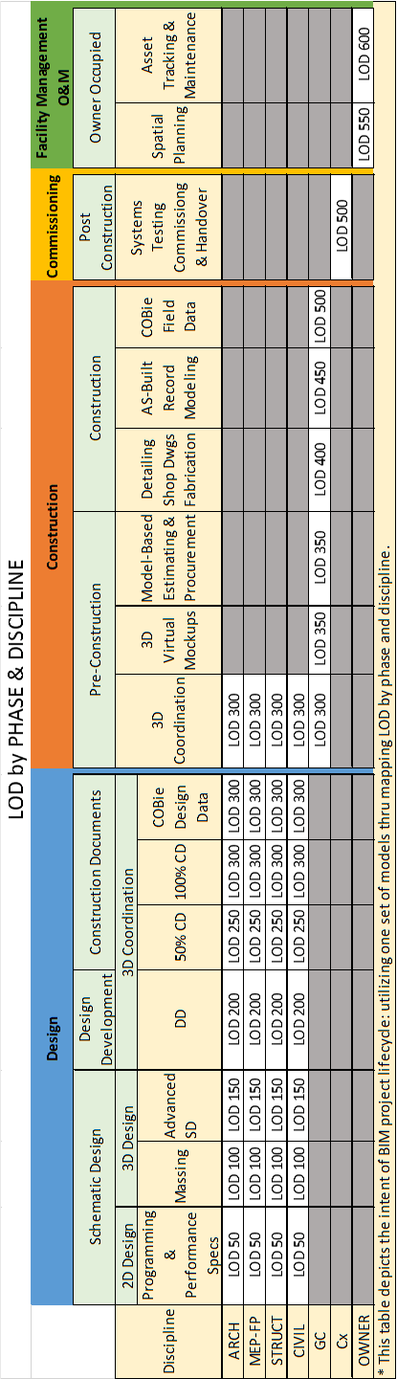

        - The Project Team shall use the following Level of Development requirements to execute the project for each given phase.
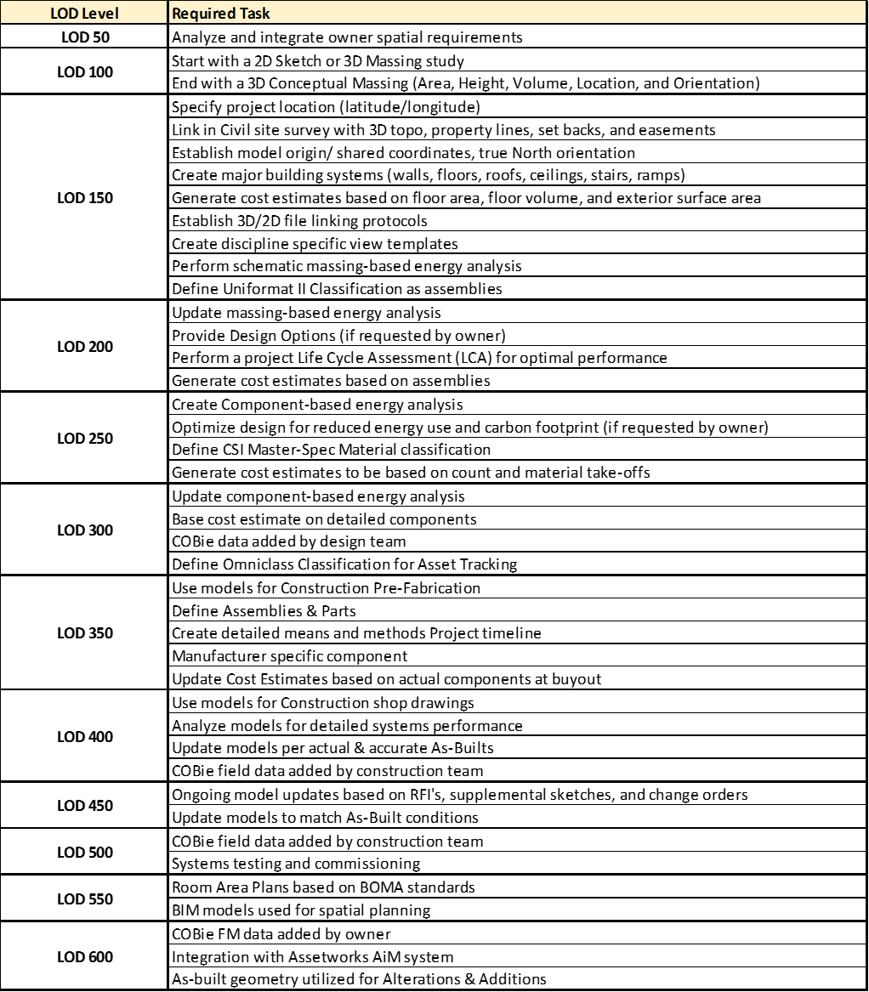

Interference reporting
  - Clearance zones required for operation, maintenance, repair and general accessibility would be indicated for those categories of objects identified in the BEP. The method for indicating clearance zones will vary depending on the category of object and potential interference checking with other categories of objects needed. For example, a door may only be required to indicate push/pull side, accessible approach and swing clearances in a 2D plan representation only, were as a mechanical equipment object may require a 3D service clearance zone volume to allow for clash detection with other 3D components. The BEP should identify what object have clearance zones associated with them and the type of representation to comply with GT standards.
  - Submit the report generated by the checking software showing conflicts have been resolved.

Program and Space Validation
  - The Design Team shall continue to track program requirements comparing against actual designed space to validate goals are being achieved. This information will either be directly included and represented in the BIM project models or by employing software specifically designed to author/import/edit program information and link to the BIM project models for validation tracking and reporting. Any programming software intended for use must be able to update actual design values compared to program values. If programming software will be used, provide examples of reports and key features of the software to GT for review prior to use on GT projects.
  - Other analysis and checking tools.
    - The Design Team is encouraged to analyze the design using software that interacts with the model in order to refine acoustics, code issues, reporting, and design issues, etc.

Systems Cost Estimating
  - The Design Team shall extract square foot and system information using BIM Authoring Software and other BIM integrated tools to support comparative costs analysis of options studied. Outputs shall be converted to spreadsheets and submitted as part of the deliverable at end of this phase.

COBie Design Data
  - At the Construction Document phase deliverable shall be an updated to include COBie fields and relevant information. The Register worksheet shall identify the types of equipment to be installed. The Component worksheet shall identify the major individual pieces of equipment individually identified at the Design Development Stage. The following worksheets shall be provided:
    - Facility – Facility or facilities referenced in the file(s)
    - Floor - Description of vertical levels
    - Space - Spaces referenced in a project
    - System - Systems referenced in a project
    - Component - Individually named components, materials and equipment

Construction Documents phase
  - During this phase of the work, the Design Team is expected to provide a higher level of BIM proficiency than the previous phases. Models and data shall be managed and coordinated by the Design Team (or the Pre-Construction Team, if required). The capability of the BIM models must be authored to provide reliable data export to each of the deliverables expected for this phase of the project. Continuing the collaborative mentality within the authoring tools, such as Coordination Monitoring and Interference Checking are mandated through this phase.
  - The Design Team shall continue development of the models created in the Preliminary Design Phase. Maintain parametric links within the respective models to enable automatic generation of all plans, sections, elevations, custom details, schedules, and data export/ import, analysis as well as 3D views. All information needed to describe the construction documents shall be graphically or alphanumerically included in and derived from these models only. Specifications are not required to be linked within the models, but will be accepted if coordinated via OmniClass.
  - Pre-Bid Interference Reports
    - Submit at 95% Construction Document Submittals
  - Program and Space Validation
    - The Design Team shall continue to use the methodology as described in section 18.

  - Detailed Energy Model
    - The Design Team is encouraged to continue to analyze the design using software that interacts with the model to refine load calculations, daylighting, natural ventilation, acoustics, and code issues and design issues. Further development of the Energy Information Model (EIM) will be part of the milestone deliverable of this phase. The results should be documented by the input assumptions about all facility use schedules, mechanical equipment assumptions, maximum and minimum weather days and other assumptions to validate subsequent energy modeling results.
  - Quantity Cost Estimating
    - The Design Team shall extract square foot area and quantity takeoff information using BIM Authoring Software and other BIM integrated tools to support comparative costs analysis of options studied. Outputs shall be converted to spreadsheets and submitted as part of the design solution justification at end of this phase.
  - COBie Design Data
    - The Construction Document set shall be an update to the Design Development COBie data set. All named products and equipment appearing in design schedules shall be listed in the Components Table. The designer shall ensure that the list of equipment provided in the COBie "Component" worksheet includes all equipment specifically identified on the design drawings or BIM model. The following worksheets shall be provided:
      - Facility – Facility or facilities referenced in the file
      - Floor - Description of vertical levels
      - Space - Spaces referenced in a project
      - System - Systems referenced in a project
      - Component - Individually named materials and equipment

Agency Coordination & Bidding Phase
  - General
    - The Design Team shall update the models with all addendum, accepted alternates and/or value enhancement proposals.
  - Contractor Bidding
    - Contractors who are bidding on GT projects are to review the BIM Execution Plan, which includes the IPP Project Plan and the GT Building Information Modeling (BIM) Guidelines & Standards for Architects, Engineers and Contractors before bidding. Contractor will follow the guidelines and requirements as set forth by the BIM Execution Plan and the IPP Methodology Plan.
  - Construction Documents Deliverable (Contract Documents)
    - Thirty days after the project is awarded for construction, the Design Team shall submit to Georgia Tech one set of the Construction Document Deliverables. This deliverable shall consist of CAD files representing every sheet in the Bid Documents. Each sheet is to have its own unique file and comply with the current GT BIM Standards. Native word processing files (Word or WordPerfect) for all specifications shall also be included. Any addenda files in their native format shall also be included.

Construction phase
  - During this Phase of the work the Design and Construction Team are mandated to work concurrently. The BIM Execution Plan will be updated to define collaborative relationships. Updated Roles and responsibilities are defined in the plan to eliminate redundancy and effective teaming for concurrent tasks.
  - The Design Team is required to update the design intent model(s) with changes made from official Construction Change Directives and as-built mark-ups maintained on site by the Contractor(s) during construction. At an interval that is decided within the BIM Execution Plan or at minimum once a month during construction the updated design intent model will be published in (.NWD) format and posted to the project site.
  - Milestone deliverables:
    - Construction Phase (Contractor)
      - BEP Review
      - Discipline Specific Coordination Models
      - Collision Detection
      - Shop Drawing Models (If Applicable)
      - Fabrication Models
      - As-Built Markups (2D/3D DWF and DWG formats)
      - Scheduling and Phasing Models
      - Operations Planning Set
        - COBie Construction worksheets
      - Beneficial Occupancy Set
        - COBie Construction worksheets
    - Construction Phase (Design Team):
      - Current As-Built Models for Each Discipline
        - BIM Execution Plan Review: The Contractor shall review the BIM Execution Plan with the Design Team and GT and submit any addenda within thirty days of contract award. The Design Team and GT will review and approve of any Addendum within fourteen days of submittal.
      - Construction Models
        - These models could include fabrication models, coordination models, or shop drawing models. These models will now be referred to as the Construction Models.
        - Modeling Requirements
          - The Construction Models should reflect the appropriate geometric properties of the materials and/or systems being submitted as well as appropriate performance data. Modeling Requirements and LoD will be specified in the AIA 202 document attached to the BEP.
          - Deliverables
            - The Contractor shall submit to the Project Team .NWD and 3D .DWF and .DWG files of all disciplines at each milestone defined under section 13. These submitted models shall be updated at each milestone to reflect project progress.
            - Additionally, the Contractor shall submit incremental .NWD model updates along with Collision Detection reports to GT at project specific intervals specified in the BEP and Section 26c.
      - COBie Construction Data
          - This data set shall be an update to the designer’s COBie worksheets. This set shall be provided at 70% Construction Completion or four (4) months prior to material completion, whichever is earlier. The following worksheets shall be provided.
          - Document - Documents referenced in this file
          - Installation - Location and serial number of installed components
          - Manual – Manufacturer provided operation, maintenance, and installation manuals for sets of/or components.
          - Warranty -Warranty information for sets of/or components
          - Spare - Spare/parts reordering info for sets of/or components
      - Beneficial Occupancy Set
        - This data set shall be an update to the Operations Planning Set. Tag numbers for valves, controls, or other "tagged" items shall be individually identified in the "Component" worksheet. The following worksheets shall be provided:
          - Document - Documents referenced in this file
          - Installation - Location and serial number of installed components
          - Manual - Instruction manuals for sets of/or components
          - Warranty -Warranty information for sets of/or components
          - Spare - Spare/parts reordering info for sets of/or components
          - Installation - Installation/operating instructions
          - Tests - Test of System and component test results
          - Certification – Installation certifications
          - Material – Special materials needed for a given Job Plan Task
          - Tool – Special tools needed for a given Job Plan Task
          - Training – Special training needed for a given Job Plan Task
          - PM – Identifies specific PM tasks and frequency
          - Safety – Identifies required safety tasks
          - Trouble –Manufacturer start-up procedures/reports
          - Start-Up & Shut-down procedures
          - Shut-Down - Emergency operating procedure

Coordination Meetings
        - Within 30 days of the notice to proceed, the Contractor shall submit a plan to the Owner for review that outlines the process for concurrent as-built documentation.
        - Methods for recording as-built information are left to the discretion of the contractor. Potential options include traditional methods, and/or periodic laser scanning of completed or partially completed primary systems coordinated with the sequence of construction. Primary systems fall into two categories.
          - Primary Architectural Systems.
            - Primary Architectural Systems include, but may not be limited to: Partition systems with structure, flooring systems, major HVAC, piping, sewerage and /or conduit systems, partition systems with bulkheads, partition systems with expansion control, vertical transportation systems with primary engineering systems, millwork and casework systems with power and data outlets, horizontal ceiling systems with window openings, bulkheads, partitions, lighting, fire protection and HVAC outlet locations, exterior skin systems with window openings, structure, roof edge conditions, parapets, roof penetrations, and equipment locations.
          - Primary Engineering Systems.
            - Primary Engineering Systems include, but may not be limited to: structural framing, primary HVAC duct runs, primary fire protection main runs, primary electrical conduits (1”+), ceiling grids layouts, primary data, audio visual, security and communication distribution systems (cable trays, etc.).

Projects without active .RVT models at the start of construction.
  - In the case of no .RVT model at the start of construction, the Contractor shall develop an .RVT model for use during construction according to the program requirement as established in the bid documents. The Contractor shall coordinate model with the Owner prior to selection. The purpose of this model shall be to house the pertinent data as established by the bid documents and program, necessary to support future facility management objectives. Additionally this model shall be the repository of final “as-built” data incorporated by either concurrent laser scanning and/or traditional recording methods for as-built conditions.

Projects with active .RVT model at the start of construction.
  - In the case of an existing .RVT model at the start of construction, the contractor shall use that model in support of the objectives for this phase.
  - Coordination with Design Team and Owner
    - On no less than a biweekly basis the contractor shall include all Project Team members, their project managers, project model managers, in a coordination meeting established for the purpose of assessing and/ or executing FM data transfers from the construction process into the .RVT model or COBie spreadsheets. The data transfer shall be coordinated with the Owner representative and the Team responsible for these activities. The deliverable is based on the FM objectives as defined in the BEP and project program.
  - Deliverables:
    - NavisWorks Files.
      - NWD files should be created at all critical coordination milestones. This record format will document a coordinated section of the model, either by area of the building or between specific critical trades. The interference report showing all applicable interference as either Approved or Resolved along with the qualified clash detection software file shall be uploaded together to GT's project collaboration system
    - Collision Detection Reports
      - All construction collision detection shall be between trades that naturally would cause construction conflicts.
      - The Contractor is to use approved collision detection software as defined in section 2g for interference reporting. Interferences reports from the qualified clash detection software should be published weekly to the GT project manager responsible for overseeing project, in a standard XML, HTML, or Text format as created by NavisWorks. These reports shall include the following information at a minimum:
        - Date of Collision Detection Report Run
        - List of all collision detected, their status, and their proposed solution
  - Collision Detection Meetings
    - The Project Team should define in the BEP and hold regularly scheduled meetings to review, or generate the collision detection reports. Review meetings are critical to the understanding and resolution of interferences.
  - Concurrent As-Builds
    - The Project Team shall submit a plan to the Owner for review that outlines the process for concurrent as-built documentation. Concurrency is mandated. Methods for recording as-built information are left to the discretion of the Project Team. The Designer owns, understands, and can make changes to the design models and understand the impact of those changes while the Contractor is the best entity to record all changes, convey them to the Design Team, and verify that the new models and documents reflect as-built conditions.
    - Potential options include traditional methods, and/or periodic laser scanning of completed or partially completed primary systems coordinated with the sequence of construction. Primary systems include, but may not be limited to structural framing, primary HVAC duct runs, primary fire protection main runs, primary electrical conduits (1”+), and ceiling grids layouts.
  - Scheduling
    - The sequence of concurrent As-Builds shall be recorded in the contractor’s project schedule as a line item event. Milestone dates are also to be identified in the approved BEP.
  - Commissioning Requirements
    - Commissioning data including but not limited to design intent, performance criteria and operations data shall be recorded and/or linked to a model as commissioning occurs throughout the project and published to the COBie deliverable. Commissioning requirements shall be coordinated with the requirements of the Owner. It shall be the contractor’s responsibility to coordinate the information sources and integrate this information into the REVIT model for transfer to COBie at the completion of the project.

Project Closeout Phase
  - The Design and Construction Teams will continue to work concurrently for the benefit of the GT deliverables. All Teams delivering BIMs and data directly exported from the BIMs will continue to develop their respective deliverables collaboratively with an emphasis on delivering concise information to GT.
  - Deliverables for Design Team:
    - The Design Team or designated as-built model contractor shall ensure that their models are updated per the contractor-recorded changes (Record Documents). Republish record documents in paper and .PDF formats. Also, submit full model(s) with all needed objects and reference drawings, in required deliverable formats. Submit all per GT professional services contract (deliverables sections) and the GT As-Builts Requirement document due 30 days after substantial completion. See Section 26e.
    - Design Team shall update their respective models with contractor-recorded changes. Republish record documents. Submit full model with all needed objects and reference drawings in original authored software and in IFC format.
    - DWG files shall be provided for all drawing sheets in addition to DWG (bind all xrefs) and IFC file formats for the BIM models. All BIM files shall be provided in RVT and NWD.
    - RVT files. See Section 32 for RVT file saving procedure.
    - All record documents shall be provided in electronic form and provide GT Archive Entry Sheet, located at: http://www.facilities.gatech.edu/dc/standards/GT_Archive_Entry_sheet.xls. All fields are to be filled out for all documents (sheets) and shall be provided at Close-out. Refer to Georgia Tech’s Yellow Book for further archiving requirements.
  - Deliverables for construction team:
    - The contractor shall submit one set of scanned field set drawings (Record Documents) in .PDF and .DWG format due 30 days after substantial completion.
    - DWG files shall be provided for all drawing sheets in addition to DWG (bind all xrefs) and IFC file formats for the BIM models. All BIM files shall be provided in RVT and NWD to reflect As-Built conditions at the end of the project. DWG file will be provided to GT for CRM’s use on-site.
    - RVT files. See Section 32 for RVT file saving procedure.
    - All record documents shall be provided in electronic form and provide GT Archive Entry Sheet, located at: http://www.facilities.gatech.edu/dc/standards/GT_Archive_Entry_sheet.xls. All fields are to be filled out for all documents (sheets) and shall be provided at Close-out.
    - O&M (Operations & Maintenance) Manuals
      - The contractor shall submit the following information to GT - two paper copies in binders and a single PDF of the O&M Manuals along with the Construction Operations Building Information Exchange (COBie) current format.
      - The make, model and serial number of each piece of installed equipment
      - The location of any equipment installed in the building
      - Manufacturer’s documents including cut sheets, installation instructions, and recommend maintenance tasks, testing or other reports. An electronic format of the O&M manuals shall be submitted along with the paper copies, the format shall be color PDF and native Excel (.XLS) files. Due 30 days after substantial completion. O&M manual documents should be independently linked to components and systems within the COBie deliverable.
      - All record documents shall be provided in electronic form and provide GT Archive Entry Sheet, located at: http://www.facilities.gatech.edu/dc/standards/GT_Archive_Entry_sheet.xls. All fields are to be filled out for all documents (sheets) and shall be provided at Close-out.

  - COBie As-Built Requirements:
    - The Contractor shall update the COBie Construction Beneficial Occupancy Set. Tag numbers for valves, controls, or other "tagged" items shall be individually identified in the "Component" worksheet due 30 days after substantial completion.

Ownership and Rights of Data.
  - GT has ownership of and to all CAD files, BIM Models, and Facility Data developed for the Project. GT may make use of this data following any deliverable.

Appendix
  - Initial Guidelines for Model Correctness
    - These guidelines are to allow GT internal assessment of a Building Model, for different uses. They reflect good modeling practices, for all types of facilities. This is an evolving set of requirements that will become more articulated as BIM experience progresses.
  - Walls
    - Revit walls that belong to the Exterior perimeter or shell, will comprise of a single wall type that reproduces the exterior and interior components of that wall type.
      - Wall segments that are made up of uniform material layering should be avoided.
      - Walls should be modeled accurately to reflect their correct height.
      - Wall height(s) should be from top of slab (or knee wall, ramp or other base) to underside of slab above or structural beam above.
      - Trim walls at corners and join wall segments as necessary.
      - Walls that are at the ceiling height must have their area space heights’ set to be the same heights.
  - Doors
    - In all design stages after Preliminary Design, all installed doors should be their intended width and height, with their swing and direction, or other opening mechanism indicated.
    - Doors and openings to be uniquely identified and tagged to the door’s functional room or space.
  - Slabs
    - In all design stages after Preliminary Design, slabs will have cutouts for all sleeves, openings and penetrations, allowing volume estimates, safety checking for construction and other uses.
    - Slab thickness should represent intended structural slab thickness, without plenum space. The gap between bottom of slab and Ceiling of space is considered potential plenum space.
    - Sloping slabs or ramps are to be modeled accurately.
  - Windows
    - In all design stages after Preliminary Design, windows will be their intended width, height and placement within walls. Window glazing will be modeled as a subcategory of the window component.
  - Curtain wall and glazing
    - In all design stages after Preliminary Design, curtain wall and glazing will be their intended width, height and placement. Horizontal and vertical mullion detail should be modeled, and be consistent with basis of design manufacturer details. Window glazing will be modeled as a subcategory of the curtain wall component.
  - Equipment
    - In all design stages after Preliminary Design, equipment will be modeled with access and maintenance space geometrically modeled, so that access codes and maintenance can be reviewed. Modeled access geometry will have an ability to be turned off.
  - Columns
    - In all design stages after Preliminary Design, all columns are to be modeled. Column structures are to extend from top of grade beam or slab, and extend to underside of beam or slab. All model component overlaps should be eliminated.
  - Space Objects
    - Space objects should cover all the interior space bounded by interior partitions and exterior walls. These should include elevator shafts (Elevator space), mechanical shaft spaces (Shaft space) multi-floor spaces (spaces above base space are “open to below” space name)
    - Space names should conform to The Post-secondary Education Facilities Inventory and Classification Manual (FICM) space name categories. Any special use or common names needed to address multi-use or other spaces not in program should be reported separately to GT so they can be included in the space program reviews.
    - In buildings with planned departmental assignments, each space will also receive a departmental name and must maintain the space program unique identifier. These names will be provided by GT at project initiation, for entry and management in the building model.
    - In general, the space object geometry shall be modeled as the perimeter of the building space bounded by walls or “virtual wall” segmentation. (The “virtual wall” is not a physical wall but instead an imaginary boundary that extends past the top of the wall to the underside of either the structure above or ceiling above)The space volume is then extruded upward to a height designating the bottom of finished ceiling height.
    - It is recommended that space floor coverage should be associative and automatically made consistent with walls if moved, to maintain consistency. Ceiling height of spaces, if there are major changes in height within a space, should be modeled to indicate changes.
    - All space objects should be tight fitting and non-overlapping.

GT Facilities Management System Data Structure
  - For importing asset data into GT’s facility management system, as provided by the contractor, the following definitions apply and are coincident to the COBie information exchange.
  - Definitions
    - Asset tag: The asset tag is based on a specific format, which is used to define a single asset, groups or systems of assets. An example of the format used is 184-HTR-01-001. 184 is the building/ facility number. HTR stands for UNIT HEATER, 01 is the floor number, and 001 indicates unit # 1. Furniture that is moveable or portable shall not be included with an asset tag.
    - Asset description: Describes the asset defined in Asset tag field.
    - Asset type: Type of asset. The value of this field is always ‘SERIALIZED’.
    - Asset group: This is a user-specified name to group assets for reporting purposes.
    - Status code: (GT Internal) This term identifies the current condition or situation of the asset, such as installed, out of service, available, rented, etc. In our case, this value is always “IN USE”.
    - Region code: (GT Internal) This is the first and highest level of the location hierarchy (Region/Facility/Property/Location) for the property. In our case, the value is always “GT-MAIN” for main campus.
    - Facility identification: Facility is the second highest level in the location hierarchy and represents a 15 character abbreviated facility name.
    - Building name: Third level in the location hierarchy, it is the specific building number where the work is to be done.
    - Floor identification: Defines the floor where the asset is located.
    - Location identification: Defines the room/location of the asset.
    - Shop: (GT Internal) The asset will be maintained by a specific shop in the organization as indicated in this field.
    - Lockout: (GT Internal) If the item is going to be taken down or otherwise unavailable because of scheduled maintenance or remediation set this tag to Yes. No is the default.
    - Manufacturer: The manufacturer of the asset.
    - Model: The model number provided by the manufacturer.
    - Serial number: Serial number provided by the manufacturer.
    - Warranty start date: The warranty start date as provided by the contractor.
    - Warranty expiration date: The warranty end date as provided by the contractor.

COBie Data Roles and Responsibilities
  - The table above describes the role and responsibility of project stakeholders involved in COBie data collection for the information exchange. During each phase of the project, data is to be collected, prepared and delivered to GT during key milestones. COBie data collection will be an iterative process. Subsequent information exchanges verify, validate and add to the previous contributors. Model and team roles will vary from project to project. The above is an example, and should be addressed on a project by project basis.

Central File Conversion Guidelines
  - These guidelines will detach a Revit project file from its associated central model received from sources outside of GT. It will also prevent the “Copied Central Model” message warning GT staff the central model has been copied or moved. Use these guidelines to open file independently from the original central model. You will not be able to synchronize changes with the original central model from the design and engineering teams. These guidelines will need to be applied to all Revit models received from outside of GT and with work-sharing enabled.
  - Detach and Preserve Worksets (Revit 2016).
    - This option maintains original workset(s) information within the model. Best Practice is to select “Detach from Central” AND “Audit” prior to opening the Revit project file. Saving the file to a location on the GT server immediately after opening will create a new central model.
  - Detach and Discard Worksets (Revit 2016)
    - This option discards the original workset information. Best Practice is to select “Detach from Central” AND “Audit” prior to opening the Revit project file. Saving the file to a location on the GT server immediately after opening will create a new non-workshared model. Discarding workset disables work-sharing and the Revit project file is converted back to a single user file.

Terminology
A
As-Built Documents: As-built documents are the collection of paper drawings or electronic drawings that typically reside in the contractor’s onsite trailer that contain mark-ups, annotations, and comments about changes that have been made to the contract documents during the construction phase.
As-Built Model: Design Intent Models that have been updated throughout the construction process. These changes and updates have been communicated from the Contractor to the Design Team through the comments, annotations, and mark-ups from the As-Built Documents. These typically, but not always, are discipline specific models.
B
BIM Execution Plan (BEP): A plan that is created from the GT BIM Execution Plan Template that is to be submitted thirty days after contract award. The BEP helps to define roles and responsibilities within a project team.
BIM Proficiency Matrix (BPM): A matrix designed to measure the expertise of a firm as it relates to using a BIM process on projects. It will be used as one of the many selection criteria during the selection process.
C
COBie (Construction Operations Building Information Exchange): COBie is a standard of information exchange that allows information to be captured during design and construction in a format that can be used during the operations of a building once completed.

Critical Path Modeling: Critical Path Modeling is a method of demonstrating Integrated Project Delivery, and tied to the AIA E202 level of development approach. It sets a plan within the Design Team that accounts for the activities of each discipline and how they interact with each other. It builds upon a critical path method for those activities, and allows the project team to schedule a complete project.
D
Design Team: The Design Team is considered the Architect and all of the consultants that provide design services for a project. These design services can be rendered at any time during the project.

DOE2 (Department of Energy Version 2): DOE2 is a file type that is an open file format. This file format is used by most energy modeling software. It is also an approved file type for LEED simulations.

DWF: DWF is a file type developed by Autodesk to be locked and non-editable file for drawing sheets and model data. It can be used as a file transfer for estimating data, markups, and other third party software. It can be a combination of 3D and 2D information within the same file.
DWG: DWG is a native AutoCAD file format. It is a widely used file format for exchanging drawing information and 3D information to different programs. While not a database file type, it still has lots of uses for exchanging information.
E
EIM (Energy Information Model): EIM is a concept of producing a “light” and “lean” model that can be used for simulating the building’s performance very early within the design process. The EIM is the process of modeling only the exterior envelope, and the interior volumes to produce a model that energy modeling software can use.

F
FICM (Post-Secondary Facilities Inventory and Classification Manual): FICM is standard that describes practices for initiating, conducting, reporting, and maintaining an institutional facilities inventory.

G
gbXML: A gbXML file is a Green Building file type. It is used to run simulations through energy modeling software. It is a widely accepted file format for those types of software.
I
IPD (Integrated Project Delivery): IPD describes a contractual relationship between all members of the project team including the Owner, Designers, Consultants, and Construction teams. It is a project delivery method that integrates people, systems, business structure and practices into a process that collaboratively harness the talents and insights of all participants to optimize project results, increase value to the owner, reduce waste, and maximize efficiency through all phases of design, fabrication, and construction.
IPD Methodology: IPD Methodology is a concept that uses methods from the IPD contracts, but does not have the contracts actually in place. It idealizes the concepts of integration of all team members to try and benefit the entire project.
IPP Methodology Plan: The IPP Methodology Plan is a declaration of how the project team will achieve the goals of an IPP Methodology. The plan can have several components and is encouraged to be part of the BEP. The completion of a Reverse Phase Schedule or Critical Path Modeling is two examples of an IPD Methodology Plan.
N
NavisWorks: NavisWorks is software that allows for the viewing of multiple model formats. This ability to “view” these files also allows NavisWorks to simulate the interaction between model files. That includes interference reporting, time lining, and coordination.
NWC: An .NWC file is a NavisWorks Cache File that is used by NavisWorks to quickly read many other file types. All linked files in NavisWorks have an .NWC file created automatically. In addition, Revit will export directly to the very small file type of .NWC for quick access by NavisWorks.
NWD: A much larger file than the .NWC, the .NWD file shows snapshots in time of a NavisWorks file. No linked files exist but all geometry is included.
NWF: The .NWF file is a native NavisWorks file that has all linked files, interferences/ collisions, markups, animations, schedules, etc.
O
Open Architecture: Open Architecture is a concept of creating a framework that helps to describe a common set of rules for how a project is created. This includes what types of software, the interoperability of the information, and how the participants interact with each other. This is different from open standards in that it promotes progress while not anchoring forward thinkers to a rigid standard.
P
Phases: The phases of a project can be describe in two different ways as the adoption of IPD terminology starts to penetrate the BIM Execution Plan and the IPD Methodology Plan. Below is a list of the traditional names followed by the IPD name.
Pre-Design/Conceptualization Phase
Schematic Design/Criteria Design Phase
Design Development/Detailed Design Phase
Construction Documents/Implementation Phase
Project Team: The Project Team is considered the combination of the Design Team, Contractor, and at times, GT faculty; a complete team needed to make holistic project decisions and approvals.
R
Record Drawing: The production of Record Drawings is the capturing of the As-Built Document’s annotation, comments, and mark-ups in a drawing format only. This does not typically include the updating of any models.
Reverse Phase Scheduling: Reverse Phase Scheduling Is a method of demonstrating Integrated Project Delivery. It sets a plan within the Design Team that accounts for the activities of each discipline and how they interact with each other. It uses the completion date as a point to work backward from to schedule all of the project’s activities.
RVT: An .RVT file is a Revit native file type. It is also the deliverable file format for all projects. This includes all of the Design Team’s models.
T
TMY2/TMY3: The TMY2/3 file format is a Typical Meteorological Year file. It is used for in conjunction with a gbXML file to create energy simulations.

References

buildingSMART Alliance (http://www.wbdg.org/pdfs/cobie_specification_sections.pdf)
General Services Administration (GSA) – 2003 National 3D-4D BIM Program (http://www.gsa.gov/portal/content/105075)
NBIMS National BIM Standard (http://www.wbdg.org/bim/nbims.php)
U.S. Army Corps of Engineers - Construction Operations Building Information Exchange (COBie) (http://www.wbdg.org/pdfs/cobie_introduction.pdf)

