Design and Construction – Email Signature Block
This new standardized signature block should be used for all new sent messages. You may elect to use a shorter signature block for forwarded or reply messages.
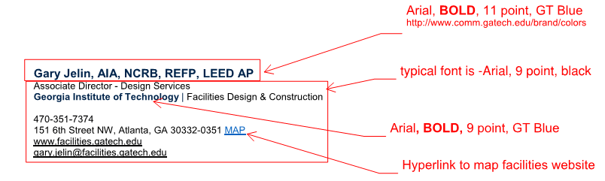
Instructions for Adding Your Signature
- Copy the below Signature Block (Highlight and Right Click, Select Copy, Keep Source Formatting)

Kim Wilson, RA
Associate Director of Construction Services
Georgia Institute of Technology | Facilities Design & Construction

404-771-6439
151 6th Street NW, Atlanta, GA 30332-0351 MAP
www.facilities.gatech.edu
kim.wilson@facilities.gatech.edu

- Open a new email. Click on the Message Tab. Click on the Signature Pull Down.
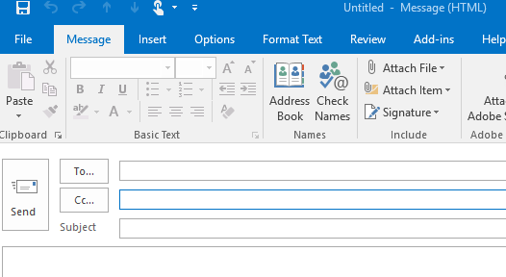

- Click on Signatures. Paste the copied signature, choosing Keep Source Formatting, into a new or existing signature and save.
- Edit the name, title, phone, and email. Save the signature.

- Set the saved signature for your New Messages.
