Supplier Contract Event (Facilities)

Overview
Enter a Supplier Contract (Contract Document) for approval review, execution by the Facilities VP, and to encumber the contract as a purchase order in Workday.
PLEASE NOTE:
- If you need to route an amendment or a change order to an existing contract, use the job aid titled Supplier Contract Amendment Event
- If you are routing contract that is old or an older quote, and the contracted completion date (End Date field) on the contract or date on the direct award quote has expired or will expire before the contracting officer can execute the contract, you will need to update the contract / quote with a current end date. Workday can not issue contracts without a current end date.

Considerations
For naming purposes, the internal Facilities Management contract number will be included in brackets at the beginning of the Contract description, e.g. [0100-19].

Initiation
Security Roles: Buyer (Facilities Contracting Officer), Supplier Contract Specialist (person routing the contract, i.e. project manager)
- Enter Create Supplier Contract into the search bar and select the link titled Create Supplier Contract. Selecting a link is the first ‘task’ in the Workday event. Create Supplier Contract.
(Shortcut, type: Cre Sup or any other partial word)
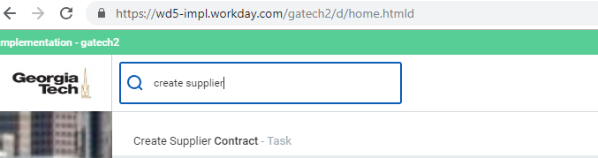

- On the following page, complete the required fields and select OK:
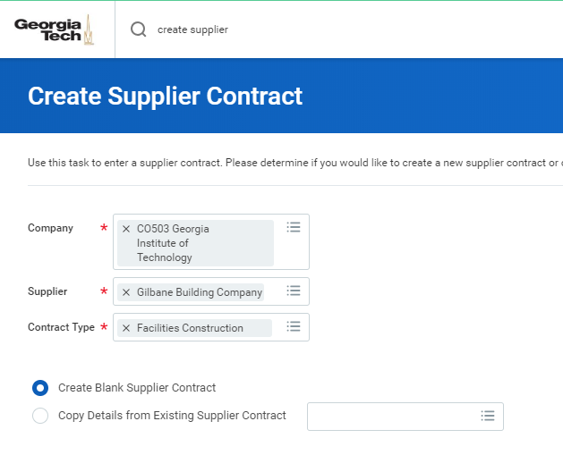
- Company – For Facilities Management projects, company will always be: CO503 Georgia Institute of Technology
- Supplier – Select the vendor for your contract award. Type in the first few letters of the vendor name to search for the vendor. Click on the vendor name to select.
- Contract Type – Supplier Contracts are configured into different Types, which define the routing for approvals of the contract. Select the type that applies to your role:
  - Facilities Campus Services: Direct reports to Director of Campus Services should select this Type.
  - Facilities Construction: Direct reports to Associate Director of Construction, or people outside of D&C who are routing a construction contract. (EH&S, OIT, Police, etc.)
  - Facilities Design: Direct reports to Associate Director of Design, or people outside of D&C who are routing a design contract. (EH&S, OIT, Police, etc.)
  - Facilities O&M: Employees in O&M select this Type.
  - Facilities Special Projects: Direct reports to Manager of Special Projects select this Type. (GTRI Contracts)
- For original contracts select Create Blank Supplier Contract. For an amendment or a change order go to the job aid titled Supplier Contract Amendment Event.

- In the Contract Information section, complete all required fields:
  - Company – Leave selected information entered on previous screen. Field may be edited as required.
  - Supplier – Leave selected information entered on previous screen. Field may be edited as required.
  - Contract Specialist – Project managers entering contracts into the system are the Contract Specialist. This field will default to the name of the person entering the contract. Leave default in place. DO NOT edit this field.
  - Buyer – In Workday, our Facilities Contracting Officers are called Buyers. This field will default to the name of the person entering the contract. This field must be edited to the appropriate Facilities contracting officer. Click the ‘X’ to delete the data in the field, and then type the first name and first few letters of the last name to search for the contracting officers name. Example: Donna Vong…. Click on the name when it pops up in the search engine to populate the field.
    - For projects greater than $200k, and Task Orders, select Donna Vongsouvan
    - For projects less than $200K, and IDIQs, select Brenda Cochran
    - For all direct awards (less than $50k Construction, less than $75K design, select Shanderika Morgan.
  - Contract Type – Leave selected information entered on previous screen. Field may be edited as required.
  - Contract Name – Enter contract name description here.
- For original contracts, enter the contract description and the letters TBD in brackets at the front of the description. The contracting officer will enter the new contract number within the brackets later.
Example: [TBD] Design for new chiller plant
- Please note: For existing contracts from prior accounting systems, drop the use of any letters from the contract numbering in brackets.
Example: [0101D-19] should be entered as [0101-19] with no ‘D’
  - Contract Reference – Facilities Contract Number field.
- The contract document being routed is an original contract, so enter TBD in the field so that the contracting officer can add the contract number later.
- Note that we are entering the contract number both in the Contract Reference field, and in the Contract Name in brackets. This is required to be entered twice due to reporting limitations in Workday.
  - On Hold – Leave blank.

Example of an Original (new) Contract
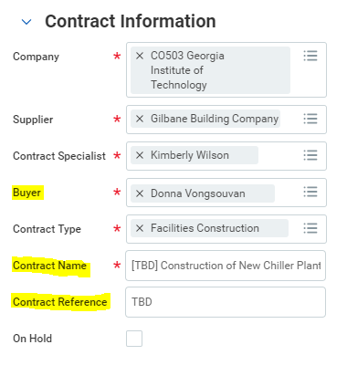

- Under the Terms and Amounts section, complete all required fields:

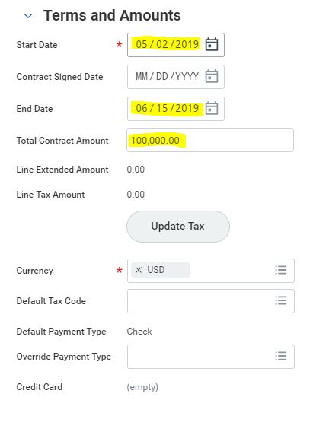
- Start Date – Enter the effective date of the contract. This date is normally identified in the first paragraph of the contract, or use the vendor quote date if it is a direct award construction contract.
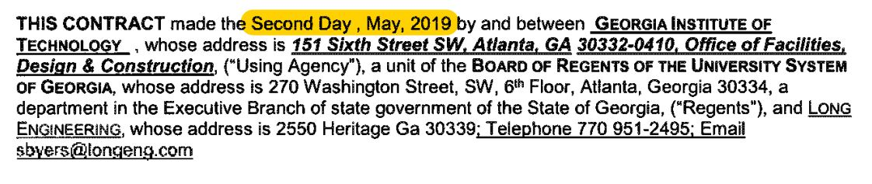
- Contract Signed Date – This field will be used by the Contracting Officers (buyers) and will be used to track the date that the contract is fully executed (fully signed). Note that this is NOT the Notice to Proceed date. The Notice to Proceed date will not be entered in a Workday field. It will be visible on the NTP document, which will be attached to the project in Workday.

- End Date – This field should be populated with the contractual completion date.

- Total Contract Amount – Enter the value of the contract / total value to be encumbered.

- Line Extended Amount – Do Not Use or populate this field.

- Line Tax Amount – Do Not Use or populate this field.

- Currency – Workday required. Auto-populates to USD. Leave as-is.

- Default Tax Code – Do Not Use or populate this field.

- Override Payment Type – Do Not Use or populate this field.

- Contract Overview - This is an optional field that may be used by Facilities Management in the future. Leave this blank until a use is defined.
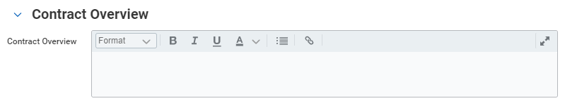
- Click on the attachments tab titled Attachments, drag and drop files or select files to attach. NOTE: There is currently a 30MB file size limit on attachments. You may have to compress large files.
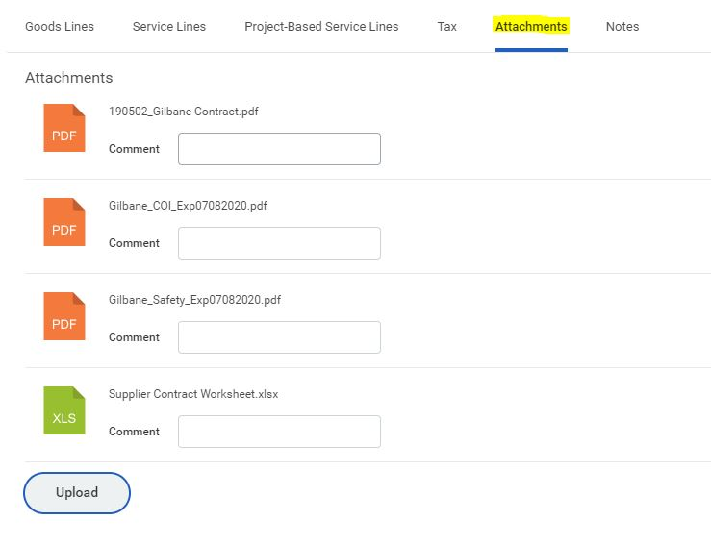
Attach documents as follows:
- Contract Documents:
  - Attach a PDF of the contract, and all supporting documents.
  - The following documents should be included as a part of the contract PDF:
    - Expedite form, as applicable, as first page of the PDF
    - Contract Document
    - E Verify
    - Bonds
    - Back up proposal / quote from vendor
  - The contract PDF should be named using Facilities file naming standards as follows: YYMMDD_Your Description, example: 190402_Gilbane Original Contract
- Additional Documents:
  - Before routing a contract, you should check the Facilities database to ensure that your vendor has current forms on file: https://facilities.gatech.edu/coi/landing
    - Insurance certificate – all vendors
    - Safety form – contractors only
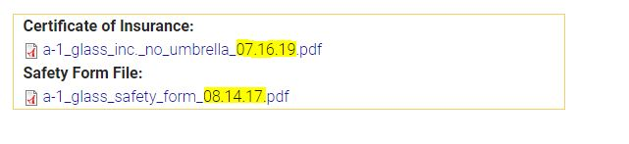
  - If any forms are missing or out of date, a current copy of the document should be routed with the contract.
  - The following documents should be included as separate PDFs and named as outlined below We are asking everyone to name these files and attach them separately to make it easier for our contracting officers to drag them into the Facilities COI database and into their procurement documentation files.
    - Insurance Certificate:

Vendorname_COI
Example: Gilbane_COI.pdf

The contracting officer will complete the date

    - Contractor Safety Forms:
Contractorname_Safety_Expirationdate
Example: Gilbane_Safety_03012020.pdf

Please use the date the form was signed by contractor

    - Bid or RFP/Q backup documentation:
Qualifications_Date
Proposals_Date
Scoresheet_Date (signed by VP Facilities)
- Supplier Contract Worksheet:
  - Complete and attach the Supplier Contract Worksheet Form. Do not rename the form. Simply drag and drop the excel file into Workday after you have completed the form. Instructions for how to complete the form are included on Tab 2 and Tab 3 of the excel file.
- Workday has many locations for adding comments. To keep things clear and consistent please:
  - Do not use Notes tab.
  - Do not use the Attachment Specific Comments Field
  - Use the CLOUD Comments field and add any applicable comments regarding the contract here. This is where notes to reviewers and notes from reviewers back to the person routing the contract should be placed.
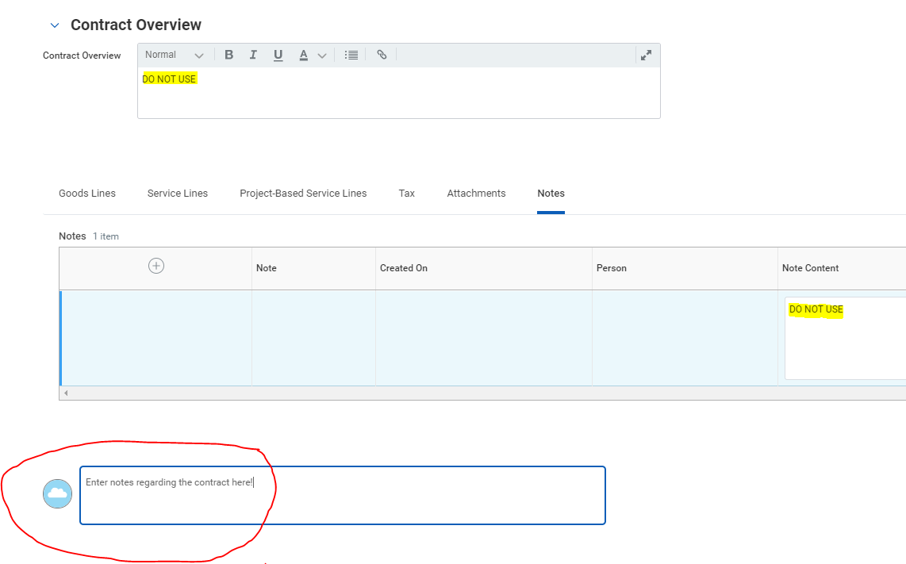
  - Vendor Email Address or Addresses: Please put the vendor email that the contract needs to be sent to in the cloud comment section.
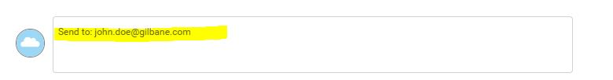
- CLICK Submit when you are complete with the contract and ready to move it forward.
- CLICK Save for Later if you want to finish the contract later.
- Click Cancel if you don’t want to save your work. This will delete the in progress contract that you are working on.
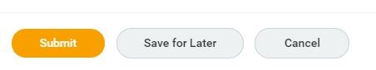

NOTICE TO PROCEED

How to Locate Your NTP Document
- Buyers (Contracting officers) will send the NTP to the vendor by email and will copy the Contract Specialist (PM) on the email so the PM is aware that the contract is complete.
- The NTP will be filed by the Buyer in the project. To locate the NTP document if you need to find it again, open your project and go to Project Plan / Attachments.
(If you don’t know how to find a project – see training called: ERP-TBD Project Module.)
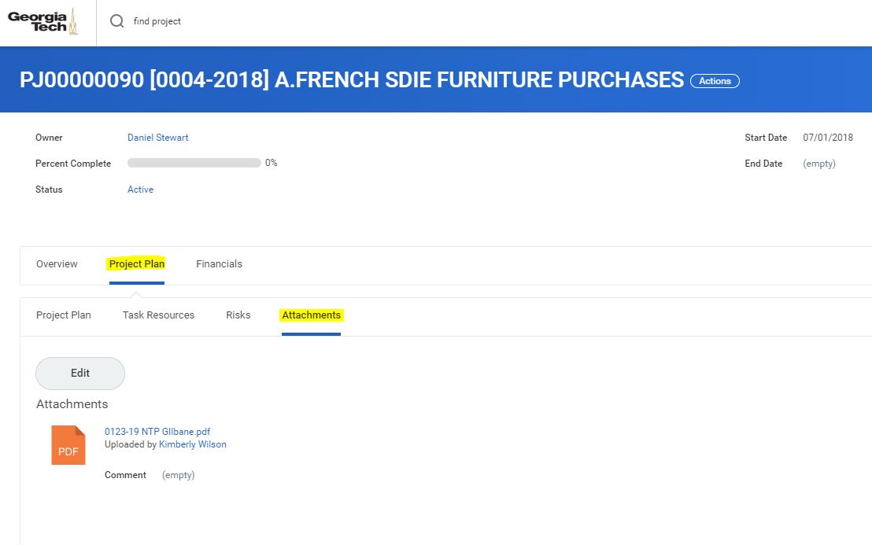

HOW TO FIND A CONTRACT

METHOD 1 – Find Supplier Contract (Query)
- Type in Find Supplier Contract at the magnifying glass search bar, top left corner of the screen. Hit Enter.
- This report can query many different variables to pull a specific list of contracts (vendor name. Note that the field for company must always be set to: C0503 Georgia Institute of Technology. Click OK to run the report after completing any search criteria fields.
- In the example below, we have sorted by the person’s name creating the contract and the company name C0503 Georgia Institute of Technology.

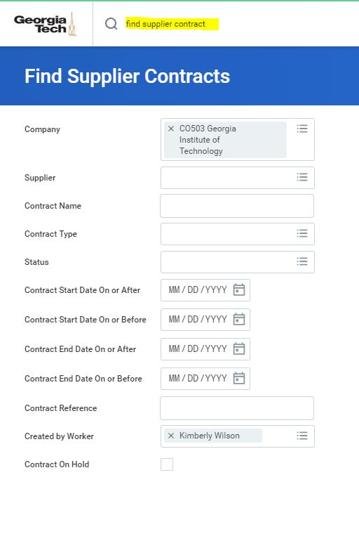

- When the table of contracts appears, note that you can sort by any column of data by clicking on the column header. In the example below, the table is sorted by Supplier.

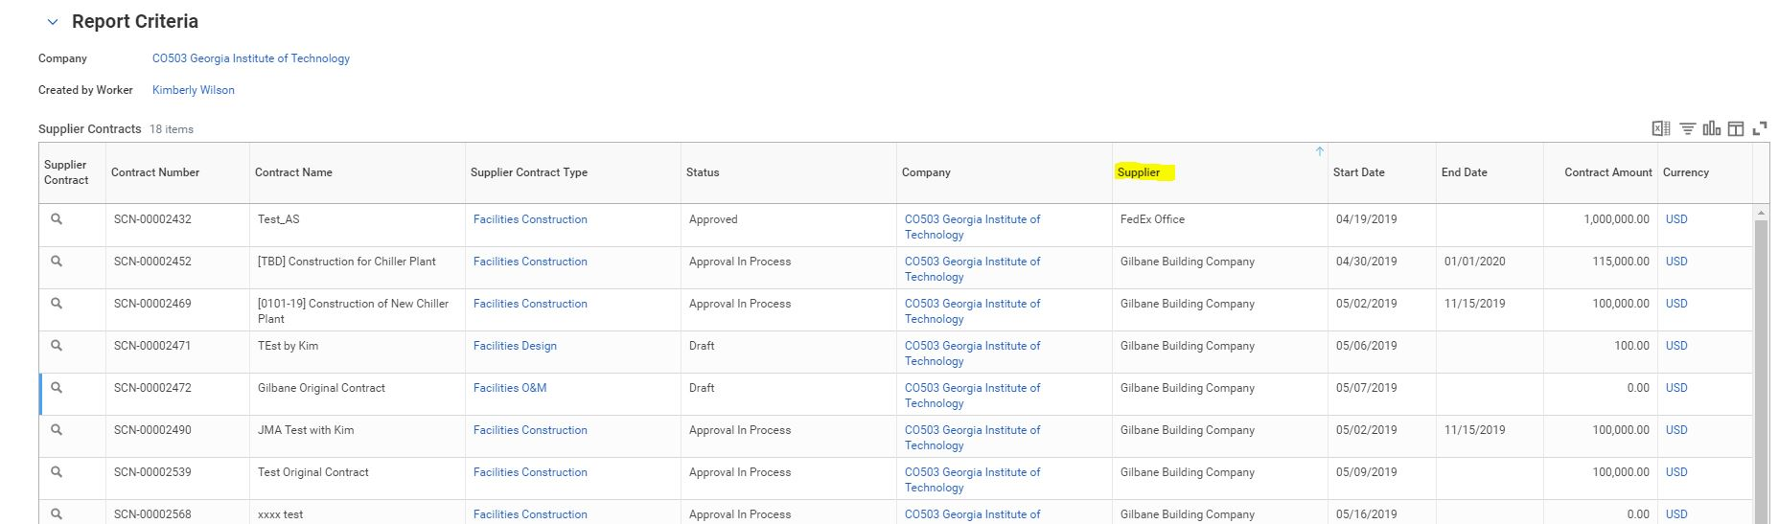

- You can drill down into the contract detail, by hoovering to the right of the magnifying glass until the orange dotted icon appears:
  - Right click to See in New Tab if you want to open a new tab, OR
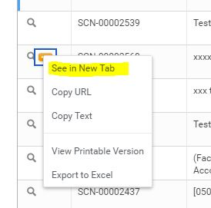
  - Click on the Contract Link to pull up the contract information.
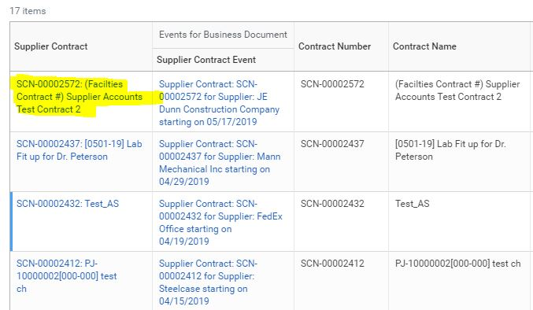
  - Process History shows the status of where the contract is in the approval workflow.

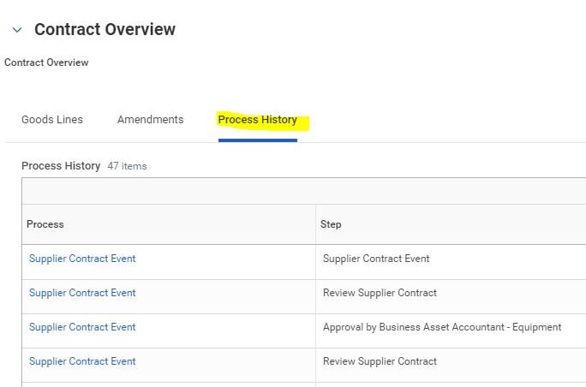

METHOD 2 – Supplier Contracts Dashboard (Report)
- Go to the magnifying glass search bar, top left corner of the screen and type: 5198. Hit enter. Click on the blue hyperlink to the report titled ERP 5198 Find Supplier Contracts Dashboard Report.
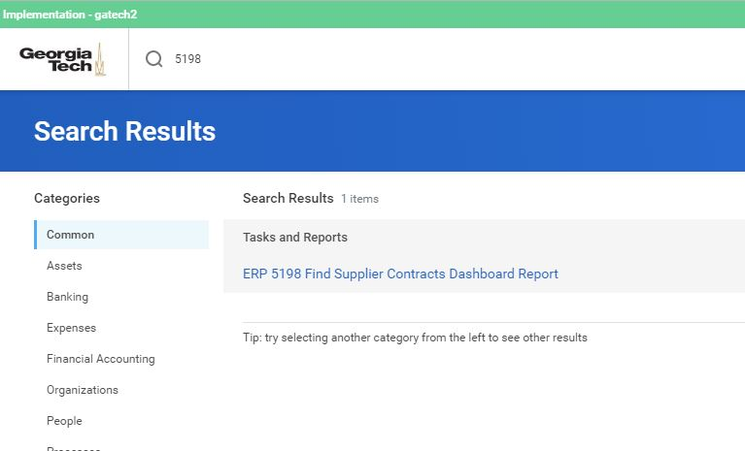

- This report can query many different variables to pull a specific list of contracts. For example: By vendor, By Contract Specialist (person entering the contract).
- Note that the field for company must always be set to: C0503 Georgia Institute of Technology.
- Example Scenarios:
Find Contracts Entered: To find contracts that you have entered, you must complete the following fields.
  - Company: C0503 Georgia Institute of Technology
  - Contract Specialist: your name
  - Status: selecting Approved or Approval in Process can narrow your search.
Find Contracts Needing Your Action: To find contracts that need your approval or have been returned to you:
  - Company: C0503 Georgia Institute of Technology
  - Awaiting Persons: your name

- Click OK
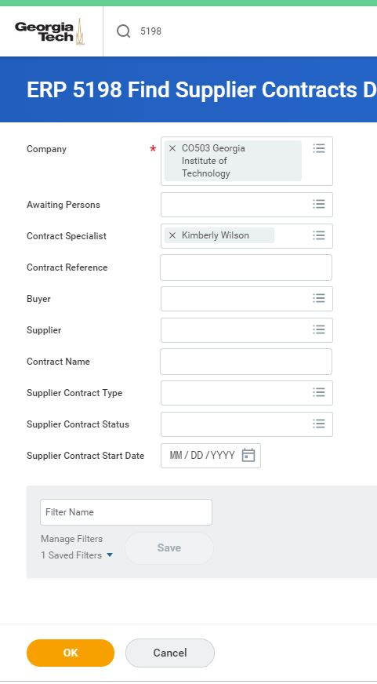

- A report grid will be produced.
  - Note that you can click the title of any column to sort by that column.
  - You can click on the Supplier Contract Event to drill down for more details on the contract. See Navigating Supplier Contract Event section to learn how to navigate and find details on the contract.
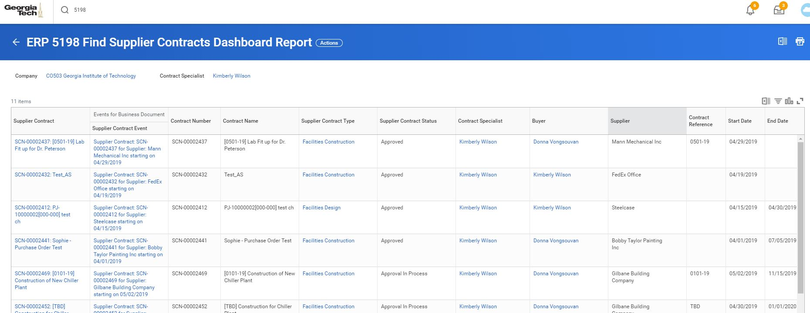
- Filters can be created for a report query that you utilize frequently as follows:
  - Set up the query as outlined above.
  - Click in the box titled Filter Name and type a name for your filter: Example: Kim’s Active Contracts
  - Click Save.
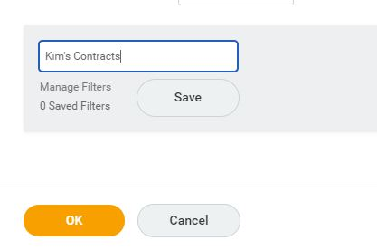

  - The next time you open the report click on the filter name, and then click OK. The query data that you have saved will populate automatically.

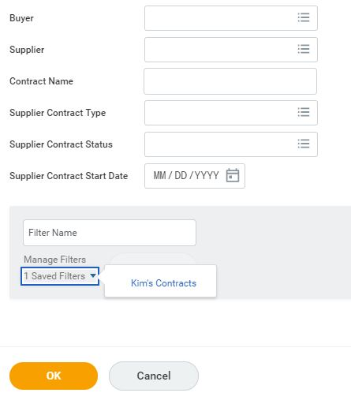

RETURNED CONTRACTS

- Contracts that are returned to you for corrections will be in your Workday inbox.
- Click on the contract that you want to correct.
- It is necessary to open two tabs to see all contract data simultaneously.
  - Open a new tab by going to Supplier Contract at the top of the screen and hover your mouse near the search magnifying icon, and the orange dotted icon will appear. In Workday this is called the orange dotted icon is called the Related Actions Button.
  - Click on the orange dotted icon. When the screen appears with the contract, RIGHT click on the blue contract name link and select See in New Tab.
  - On the new tab, hover your mouse near the search magnifying icon, and the orange dotted icon will appear. Click the orange dotted icon (Related Actions Button) then Additional Data, then View All.
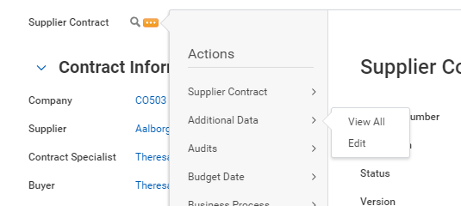

- Notes from Reviewer: Notes from the reviewer regarding why the contract has been returned will be at the bottom of the Review Supplier Contract tab. They are located next to the blue note clouds.
- Make Revisions, Add Attachments, Add Notes: Review the comment and make appropriate revisions. Note that you can add attachments or replace attachments at this time. You can also add a note back to the reviewer – Use the blue cloud notes.
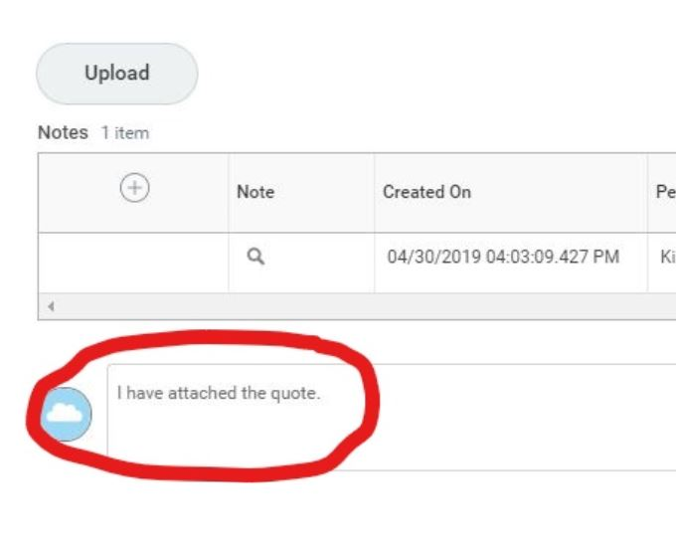

- Contract Review Action Options:
  - Submit: This moves the contract back to the reviewer in the workflow, that you select.
  - Save for Later: This option saves the changes and exits out of the contract. You can return to the contract later and any changes will remain.
  - Cancel: This option discards changes and exits out of the contract.

FACILITIES APPROVAL STEP
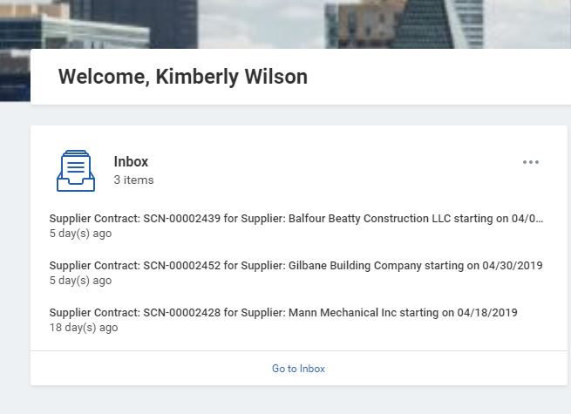
- Contracts that are ready for review will be in your Workday inbox.
- Click on the contract that you want to review first.
- Contract Data Fields:
  - Review all contract data on these screens.

- Review Attachments:
  - To open attachments, click on the attachment link.
  - Use the arrows on the attachments to the right and left to navigate through the pages of the attachment.
  - Click on the arrow in the upper left-hand corner of the black bar to close out of the attachment.
- Return to Sender for Corrections: Note that if any changes are required to fields or attachments, the contract will need to be routed back to the Contract Specialist (person routing the contract) for revisions.
- Contract Review Action Options:
  - Approve: On the tab titled Review Supplier Contract, select the Approve button at the bottom of the screen to approve the contract.
  - Send Back: On the tab titled Review Supplier Contract, select the Send Back button at the bottom of the screen. Click on the name of the person who initiated the contract, or another person in the review workflow to send the contract back. Add notes in the comment box associated with the Send Back button to explain why the contract has been returned. Remember that the only person in the workflow who can edit the contract data or attachments is the contract initiator.
  - Add Approvers: On the tab titled Review Supplier Contract, select the Add Approvers if additional review outside of the workflow is required ad hoc. Type the first name and first few letters of the person’s last name to search for the person to add. Select the person and add a note regarding why they may need to review the contract.

