Supplier Contract Amendment Event - Facilities

Overview
Enter a Supplier Contract Amendment for approval review, execution by the Facilities VP, and to encumber as a change to the Original Contract and associated purchase order in Workday. Supplier Contract Amendments include:
- Amendments (professional service and general consulting agreements)
- Lump Sum Change Orders (construction)
- Component Change Orders (construction)
- GMP Change Orders (construction)

Considerations
Policies related to this process may be found in the Business & Finance Policy Book.
- Initiate a Supplier Contract Amendment to renew, extend, terminate or change a Supplier Contract after transaction have been made on the contract.

Initiation

- KEY NOTES:
  - If you are routing an amendment or a change order, and the contracted completion date (End Date field) on the contract has expired, your change order or amendment MUST include a time extension and will need to establish a new completion date / end date for the contract.
  - If you already have a Supplier Contract Amendment in approval, you WILL NOT BE ABLE TO ENTER ANOTHER AMENDMENT, for that particular contract, until that amendment leaves the contracting officer's queue.
- Enter Create Supplier Contract Amendment into the search bar to start. Partial words or fields will also work.
- Locate Your Original Contract:
  - Amendments and change orders must be linked to the Original Contract, and the first step is to locate your contract.
  - Note: Your original contract will not appear as available to change until it has left the contracting officer’s queue.
  - You can search for contracts in variety of ways by using the vendor name, the Facilities Contract number, or other words that are in the contract title.
  - Enter your search criteria and hi enter. (Example: Gilbane – a vendor name)
  - Pick the contract document from the list that appears by clicking the circular check box and then click OK.
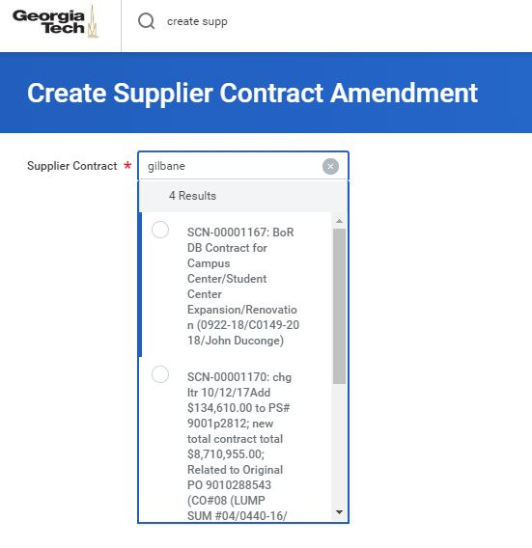

- A new screen will appear. You will need to complete TWO fields on this screen: Amendment Type and Amendment Date.
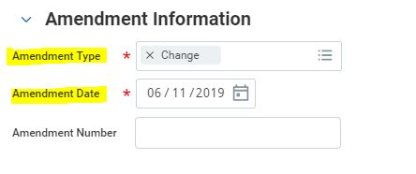
- Under the Amendment Information header, enter the following fields.
  - Amendment Type - For design amendments and construction change orders, select Change.
  - Amendment Date – Enter the date of the amendment or change order document.
  - Amendment Number – Leave blank. Buyer (contracting officer) will complete.
  - Amendment Signed Date – Leave blank. Buyer (contracting officer) will enter the date that the amendment or change order is executed. For Facilities D&C, this field will serve as the field for the Notice to Proceed date. This field will be completed by the Buyer (contracting officer) later.
  - Amendment Description – Leave blank. Buyer (contracting officer) will complete.

- The Contract Information, and Terms and Amounts section will populate from your Original Contract. Leave As-Is.

- Add Attachments:
  - Click on the attachments tab titled Attachments, drag and drop files or click the Upload button to upload files. NOTE: There is currently a 30MB file size limit on attachments. You may have to compress large files.
  - Contract Documents:
    - The amendment or change order PDF document should be named using Facilities file naming standards as follows: YYMMDD_Your Description, example: 190402_Gilbane Change Order 1.
    - The following documents should be included as a part of the contract PDF:
      - Bond Rider Increase (if they need to be increased)
      - Back up proposal / quote from vendor

- Additional Documents:
  - Before routing a contract, you should check the Facilities database to ensure that your vendor has current forms on file: https://facilities.gatech.edu/coi/landing
    - Insurance certificate – all vendors
    - Safety form – contractors only
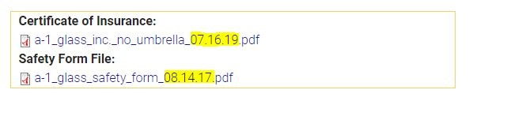
  - If any forms are missing or out of date, a current copy of the document should be routed with the contract.
  - The following documents should be included as separate PDFs and named as outlined below We are asking everyone to name these files and attach them separately to make it easier for our contracting officers to drag them into the Facilities COI database and into their procurement documentation files.
    - Insurance Certificate:
Vendorname_COI
Example: Gilbane_COI.pdf
The contracting officer will complete the date
    - Contractor Safety Forms:
Contractorname_Safety_Expirationdate
Example: Gilbane_Safety_03012020.pdf
Please use the date the form was signed by contractor
  - Supplier Contract Worksheet Form:
    - Complete and attach the Supplier Contract Worksheet Form. Do not rename the form. Simply drag and drop the excel file into Workday after you have completed the form.
    - Instructions for how to complete the form are included on Tab 2 and Tab 3 of the excel file.
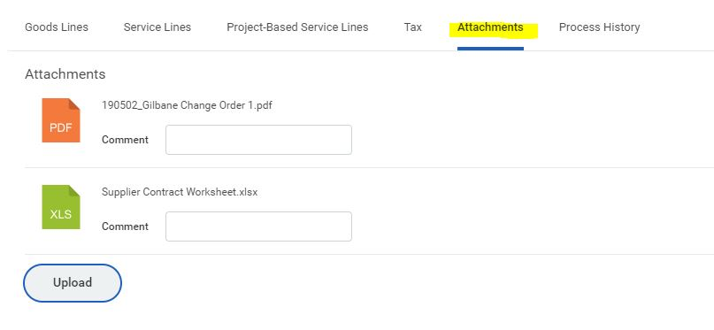
- Workday has many locations for adding comments. To keep things clear and consistent please:
  - Do not use Notes tab.
  - Do not use the Attachment Specific Comments Field
  - Use the CLOUD Comments field and add any applicable comments regarding the contract here. This is where notes to reviewers and notes from reviewers back to the person routing the contract should be placed.

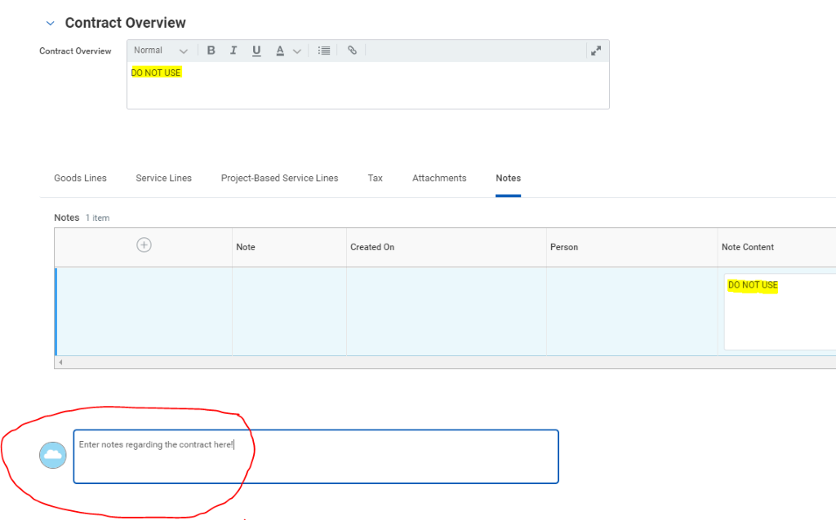
  - Vendor Email Address or Addresses: Please put the vendor email that the contract needs to be sent to in the cloud comment section.
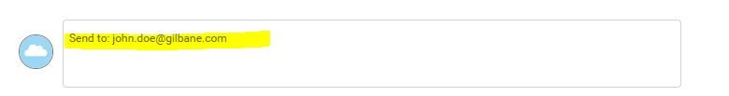
- CLICK Submit when you are complete with the contract and ready to move it forward.
- CLICK Save for Later if you want to finish the contract later.

- Click Cancel if you don’t want to save your work. This will delete the in progress contract that you are working on.
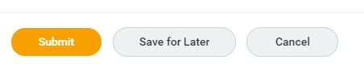

Finding ‘Save for Later’ Amendments

- If you do not have time to finish entering an amendment, and click Save for Later, you will have to go to the original contract to locate your amendment and open it up for editing.
- Locate your contract using Find Supplier Contract. See the Supplier Contract Event instructions for how to run this query.
- Note that at the top of the Supplier Contract there is a status bar indicating that an Amendment is in progress.
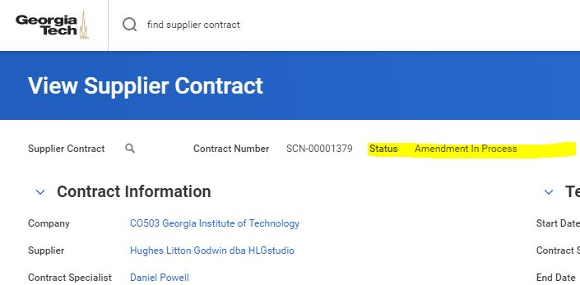

- Once you have located and opened your contract, go to the orange related actions button (dotted twinkie) at the upper left-hand corner of your screen. Select Supplier Contract, Edit Amendment.
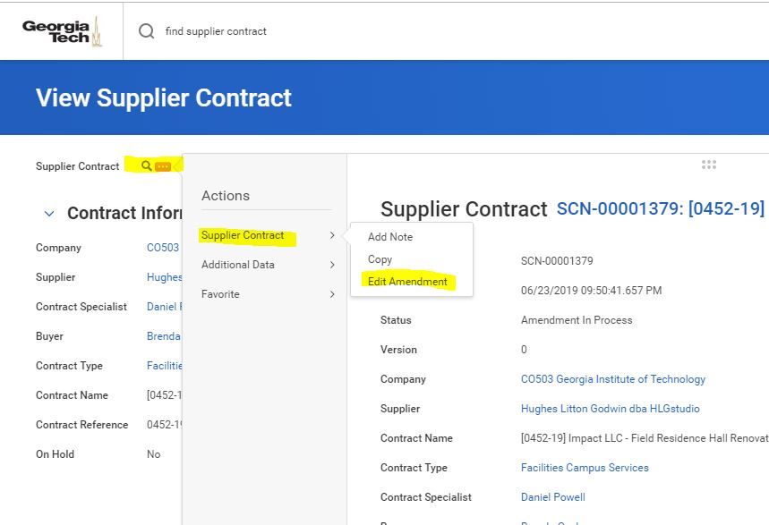
- Once the amendment opens, and you are complete with your edits, select Submit.

